Intelligent Support Ticket System

21CSC205P Database Management Systems
A MINI PROJECT REPORT

Submitted by
ALEEM-UL-ZAMAN-BABA [RA2411026010520]
TAWHEED SAJAD BAZAZ [RA2411026010527]

Under the Guidance ofx

Dr.A. Sheryl Oliver
Assistant Professor, CINTEL

in partial fulfillment of the requirements for the degree of

BACHELOR OF TECHNOLOGY

in

COMPUTER SCIENCE ENGINEERING

with specialization in Artificial Intelligence and Machine Learning



DEPARTMENT OF COMPUTATIONAL INTELLIGENCE

SCHOOL OF COMPUTING

COLLEGE OF ENGINEERING AND TECHNOLOGY
SRM INSTITUTE OF SCIENCE AND TECHNOLOGY

KATTANKULATHUR- 603 203

MAY 2026



SRM INSTITUTE OF SCIENCE AND TECHNOLOGY -- KATTANKULATHUR – 603 203

BONAFIDE CERTIFICATE

Certified that Project report titled “Intelligent Support Ticket System” is the bonafide work of “ALEEM-UL-ZAMAN-BABA [RA2411026010520], TAWHEED SAJAD BAZAZ [RA2411026010527]” who carried out the 21CSC205P Database Management Systems mini project work under my supervision.

COURSE FACULTY | HEAD OF THE DEPARMENT
Assistant Professor  Department Of Computational Intelligence | PROFESSOR AND HEAD  Department Of Computational Intelligence

ABSTRACT

In the modern IT service management landscape, help desks are often overwhelmed by the sheer volume of incoming support requests. Traditional methods of manual ticket triage—sorting, classifying, and assigning tickets to the appropriate personnel—are time-consuming, prone to human error, and scalable only by increasing headcount. This inefficiency leads to delayed response times and decreased customer satisfaction. To address these challenges, this project proposes the development of an Intelligent Support Ticket System, an automated solution designed to streamline the incident management process through the application of Artificial Intelligence (AI) and Machine Learning (ML).
The proposed system utilizes Natural Language Processing (NLP) techniques to analyze the unstructured text data within user-submitted tickets. By preprocessing this data and feeding it into a trained machine learning classifier, the system can automatically predict the appropriate category (e.g., Hardware, Software, Network) and assign a priority level based on the sentiment and urgency detected in the text. Furthermore, the system incorporates an intelligent routing algorithm that dispatches the ticket to the most suitable support agent based on their expertise and current workload.
The implementation of this system aims to significantly reduce the Mean Time to Resolution (MTTR) and alleviate the administrative burden on support staff. By automating the initial triage phase, the Intelligent Support Ticket System ensures that critical issues are prioritized effectively, resources are utilized optimally, and the overall efficiency of the IT support workflow is enhanced.

TABLE OF CONTENTS

Chapter No. | Title | Page no.
 | ABSTRACT | 3
1 | Problem understanding, Identification of Entity and Relationships, Construction of DB using ER Model | 7
2 | Design of Relational Schemas, Creation of Database and Tables for their project | 10
3 | 3.1Writing queries based on the concepts of Aggregate functions, constraints, sets | 18
 | 3.2 Writing complex queries based on subqueries, joins and views | 20
 | 3.3 Writing complex queries based on the concepts of functions, Triggers, Cursors and Exception Handling | 23
4 | 4.1 Analysing the pitfalls, identifying the dependencies, and applying Normalizations- 1NF, 2NF, 3NF | 39
 | 4.2 Analysing the pitfalls, identifying the dependencies, and applying Normalizations- 4NF, 5NF | 46
5 | Implementation of concurrency control and recovery mechanisms. | 48
6 | Front-end And Back-End Implementation code | 62
7 | Results and Discussions | 67

LIST OF FIGURES

Figure No. | Name | Page no.
1 | ER diagram of Intelligent Support Ticket System | 9
2 | Relational Schema for Intelligent Support Ticket System | 10
3 | Login Screen | 67
4 | Customer Dashboard | 67
5 | Complaint Submission | 68
6 | Agent Workspace | 68
7 | Ticket View | 69
8 | Administrator Control Center | 69
9 | Active Issues Dashboard | 70
10 | Global Oversight | 70
11 | Agent Registry | 71
12 | Screenshot Of User Table | 72
13 | Screenshot Of Tickets Table | 73
14 | Screenshot of Ticket_Updates Table | 73
15 | Screenshot of Categories Table | 74
16 | Screenshot of AI_Analysis Table | 74

LIST OF TABLES

Figure No. | Name | Page no.
1 | Users table | 15
2 | Categories table | 15
3 | Tickets table | 15
4 | Ticket_Updates table | 16
5 | AI_Analysis Table | 16

CHAPTER 1

PROBLEM UNDERSTANDING, IDENTIFICATION OF ENTITY AND RELATIONSHIPS, CONSTRUCTION OF DB USING ER MODEL FOR THE INTELLIGENT SUPPORT TICKET SYSTEM

  - Introduction
In the modern IT service management landscape, help desks are often overwhelmed by the sheer volume of incoming support requests. Traditional methods of manual ticket triage—sorting, classifying, and assigning tickets to the appropriate personnel—are time-consuming, prone to human error, and scalable only by increasing headcount. To address these challenges, this project proposes the development of an Intelligent Support Ticket System, an automated solution designed to streamline the incident management process through the application of Artificial Intelligence (AI).

  - Motivation
The primary motivation behind this project is the inefficiency that leads to delayed response times and decreased customer satisfaction within traditional help desks. The implementation of this system aims to significantly reduce the Mean Time to Resolution (MTTR) and alleviate the administrative burden on support staff.
  - Scope
The scope of this project encompasses the design and development of a relational database to manage support workflows, integrated with the Gemini AI API for text analysis. The system focuses on automating the initial triage phase to ensure that critical issues are prioritized effectively and resources are utilized optimally.

  - Problem Statement
IT support teams lack an automated, intelligent mechanism to categorize and prioritize incoming unstructured text queries, resulting in manual bottlenecks, misrouted tickets, and delayed resolution times for critical technical issues.

  - Project Requirements
• Database Management System: MySQL for handling structured relationship data.
• AI Integration: Gemini API for analyzing ticket descriptions to generate priority levels.
• Core Features: User authentication, ticket creation, automated AI predictions, agent assignment, and conversational updates.

  - Identification of Entity and Relationships
Based on the system design, the following entities and relationships have been identified:
- Entities: Users, Tickets, Categories, ticket_update, AI_Analysis.
- Relationships:
  - Creates: A User Creates many Tickets (1:M).
  - Assigned: A Category is Assigned to many Tickets (1:M).
  - Updates: A Ticket has multiple updates via the ticket_update entity (1:M).
  - Predicts: A Ticket generates Predicts for AI_Analysis (1:1)

  - Construction of DB Using ER Model for the Intelligent Support Ticket System

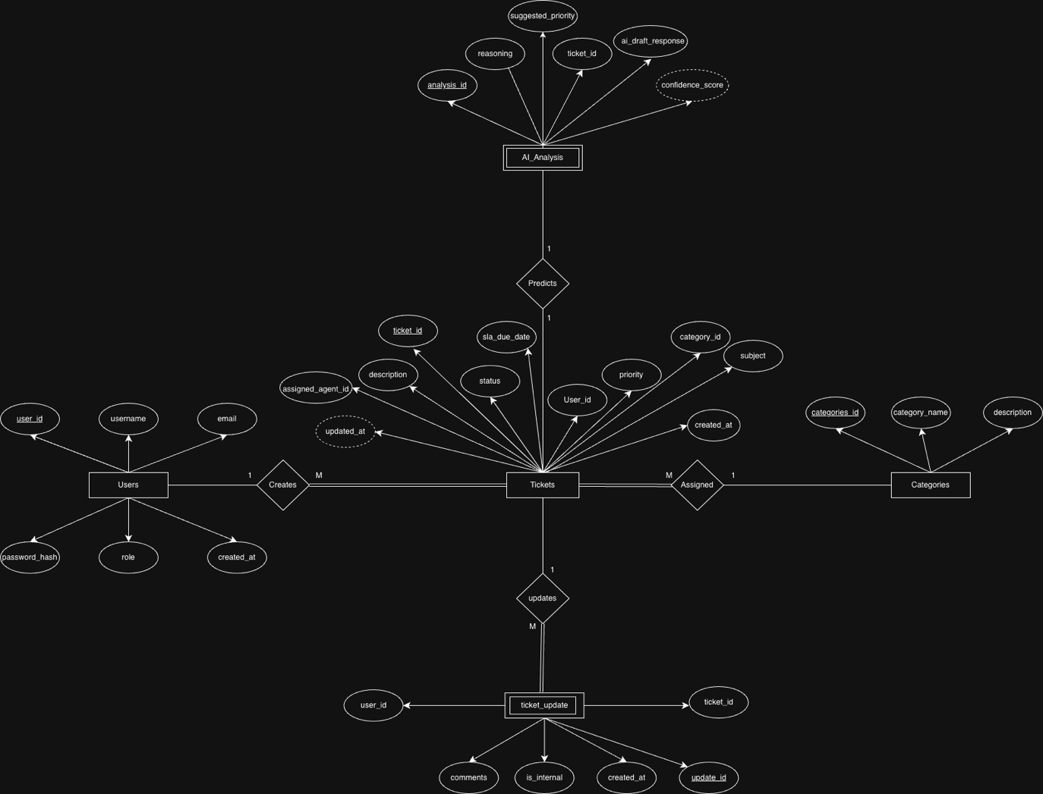
Figure 1.7.1: ER diagram of Intelligent Support Ticket System

Chapter 2
Design of Relational Schemas, Creation of Database and Tables for Intelligent Support Ticket System

2.1 Relational Schema for Intelligent Support Ticket System
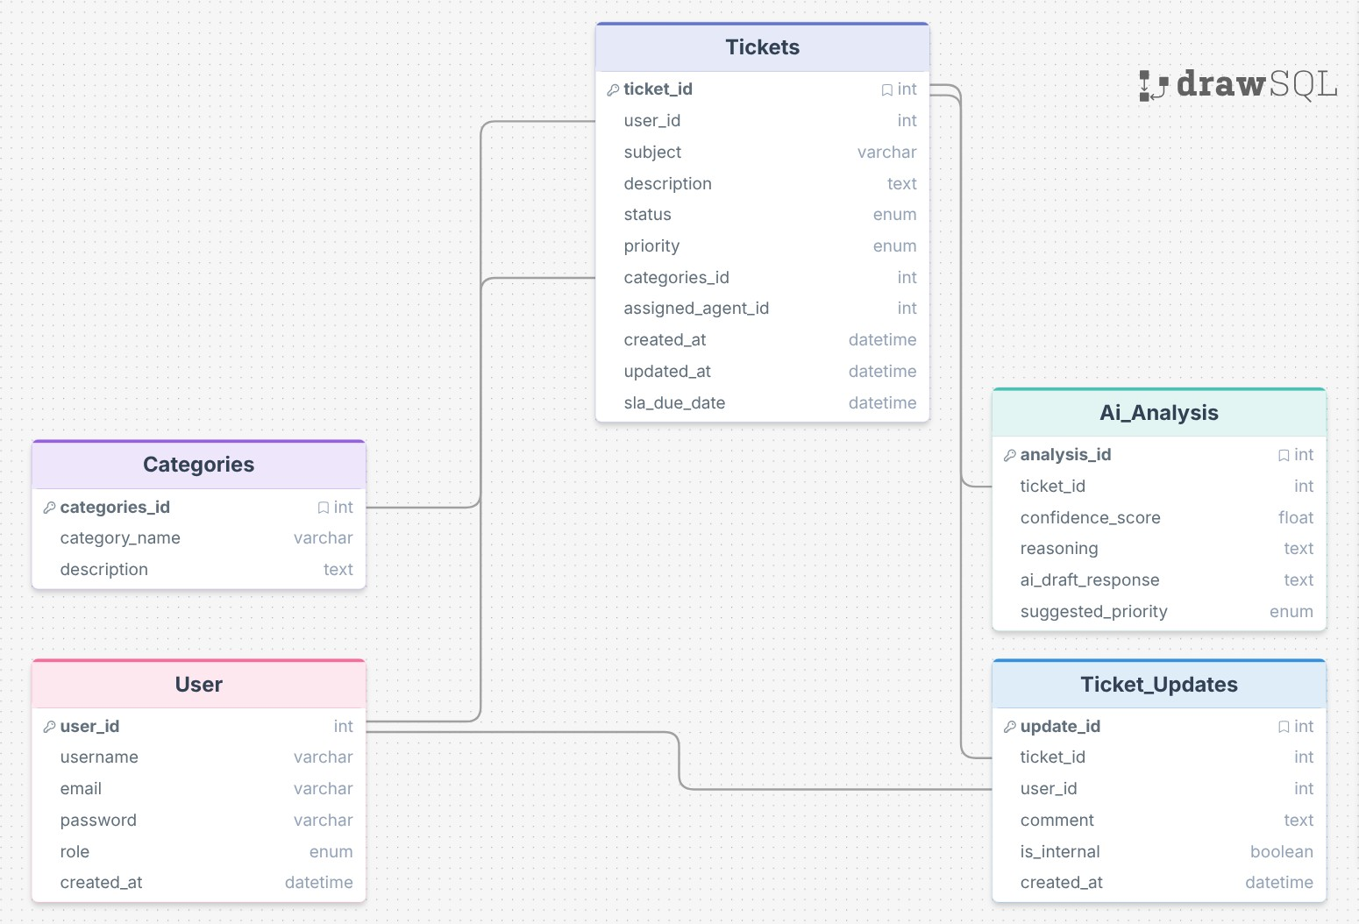
Figure 2.1.1: Relational Schema for Intelligent Support Ticket System
The figure 2.1 depicts the relational schema for the Intelligent Support Ticket System, illustrating the primary and foreign key constraints linking the users to their tickets and corresponding AI predictions
The relational schema maps the ER diagram into a structured table format.
- Users (user_id, username, email, password_hash, role, created_at)
- Categories (categories_id, category_name, description)
- Tickets (ticket_id, subject, description, status, priority, sla_due_date, created_at, updated_at, user_id, categories_id, assigned_agent_id)

- AI_Analysis (analysis_id, suggested_priority, confidence_score, reasoning, ai_draft_response, ticket_id)
- Ticket_Updates (update_id, comments, is_internal, created_at, ticket_id, user_id)

2.2 Description of Tables
Table 2.1: Users
- Purpose: Stores information about customers, agents, and administrators.
- Primary Key: user_id (INTEGER)
- Data Types and Constraints:
  - user_id: INT, Primary Key, Not Null, Auto Increment
  - username: VARCHAR(50), Not Null
  - email: VARCHAR(100), Not Null, Unique
  - password_hash: VARCHAR(255), Not Null
  - role: ENUM('Customer', 'Agent', 'Admin'), Default: 'Customer'
  - created_at: TIMESTAMP, Default: Current Timestamp
Table 2.2: Tickets
- Purpose: The core table storing support requests and SLA deadlines.
- Primary Key: ticket_id (INTEGER)
- Data Types and Constraints:
  - ticket_id: INT, Primary Key, Auto Increment
  - user_id: INT, Foreign Key (Users), ON DELETE CASCADE
  - categories_id: INT, Foreign Key (Categories), ON DELETE CASCADE
  - assigned_agent_id: INT, Foreign Key (Users), ON DELETE SET NULL
  - subject: VARCHAR(150), Not Null
  - description: TEXT, Not Null
  - status: ENUM('Open', 'In Progress', 'Resolved', 'Closed'), Default 'Open'
  - priority: ENUM('Low', 'Medium', 'High', 'Critical'), Default 'Medium'
  - sla_due_date: TIMESTAMP, Nullable

Table 2.3: AI_Analysis
- Purpose: Stores the AI's reasoning, priority suggestions, and drafted responses.
- Primary Key: analysis_id (INTEGER)
- Data Types and Constraints:
  - analysis_id: INT, Primary Key, Auto Increment
  - ticket_id: INT, Foreign Key (Tickets), ON DELETE CASCADE
  - suggested_priority: ENUM('Low', 'Medium', 'High', 'Critical')
  - confidence_score: FLOAT
  - reasoning: TEXT
  - ai_draft_response: TEXT
Table 2.4: Ticket_Updates
- Purpose: Stores the chronological chat thread and internal agent notes.
- Primary Key: update_id (INTEGER)
- Data Types and Constraints:
  - update_id: INT, Primary Key, Auto Increment
  - ticket_id: INT, Foreign Key (Tickets), ON DELETE CASCADE
  - user_id: INT, Foreign Key (Users), ON DELETE CASCADE
  - comments: TEXT, Not Null
  - is_internal: BOOLEAN, Default FALSE
Table 2.5: Categories
- Purpose: Stores the different issue classifications used to organize and route incoming tickets.
- Primary Key: categories_id (INTEGER)
- Data Types and Constraints:
  - categories_id: INT, Primary Key, Auto Increment
  - category_name: VARCHAR(50), Not Null, Unique
  - description: TEXT, Nullable

2.3 Creation of Database and Tables - DDL Commands
CREATE DATABASE IntelligentTicketSystem;
USE IntelligentTicketSystem;

CREATE TABLE Users (
user_id INT AUTO_INCREMENT PRIMARY KEY,
username VARCHAR(50) NOT NULL,
email VARCHAR(100) NOT NULL UNIQUE,
password_hash VARCHAR(255) NOT NULL,
role ENUM('Customer', 'Agent', 'Admin') DEFAULT 'Customer',
created_at TIMESTAMP DEFAULT CURRENT_TIMESTAMP
);

CREATE TABLE Categories (
categories_id INT AUTO_INCREMENT PRIMARY KEY,
category_name VARCHAR(50) NOT NULL UNIQUE,
description TEXT
);

CREATE TABLE Tickets (
ticket_id INT AUTO_INCREMENT PRIMARY KEY,
user_id INT NOT NULL,
categories_id INT NOT NULL,

assigned_agent_id INT,
subject VARCHAR(150) NOT NULL,
description TEXT NOT NULL,
status ENUM('Open', 'In Progress', 'Resolved', 'Closed') DEFAULT 'Open',
priority ENUM('Low', 'Medium', 'High', 'Critical') DEFAULT 'Medium',
created_at TIMESTAMP DEFAULT CURRENT_TIMESTAMP,
updated_at TIMESTAMP DEFAULT CURRENT_TIMESTAMP ON UPDATE CURRENT_TIMESTAMP,
FOREIGN KEY (user_id) REFERENCES Users(user_id),
FOREIGN KEY (categories_id) REFERENCES Categories(categories_id),
FOREIGN KEY (assigned_agent_id) REFERENCES Users(user_id)
);

CREATE TABLE `AI_Analysis` (
`analysis_id` int NOT NULL AUTO_INCREMENT,
`ticket_id` int NOT NULL,
`suggested_priority` enum('Low','Medium','High','Critical') DEFAULT NULL,
`confidence_score` float DEFAULT NULL,
`reasoning` text,
`ai_draft_response` text,
PRIMARY KEY (`analysis_id`),
KEY `ticket_id` (`ticket_id`),
CONSTRAINT `ai_analysis_ibfk_1` FOREIGN KEY (`ticket_id`) REFERENCES `Tickets` (`ticket_id`) ON DELETE CASCADE );

CREATE TABLE ticket_updates (
update_id INT AUTO_INCREMENT PRIMARY KEY,
ticket_id INT NOT NULL,
user_id INT NOT NULL,
comments TEXT NOT NULL,
is_internal BOOLEAN DEFAULT FALSE,
created_at TIMESTAMP DEFAULT CURRENT_TIMESTAMP,
FOREIGN KEY (ticket_id) REFERENCES Tickets(ticket_id),
FOREIGN KEY (user_id) REFERENCES Users(user_id)
);
2.4 Insertion of tuples into the table – DML commands
Insert SQL (for all tables)
Example:
INSERT INTO Users (username, email, password_hash, role) VALUES
('JohnDoe', 'john@example.com', 'hash123', 'Customer'),
('AgentSmith', 'smith@support.com', 'hash456', 'Agent');
Users table:
Username | Email | Password | Role
JhonDoe | john@example.com | Hash123 | Customer
AgentSmith | smith@support.com | Hash456 | Agent

INSERT INTO Categories (category_name, description) VALUES ('Hardware', 'Physical device issues'), ('Software', 'Application bugs and errors');
Category_name | Description
Hardware | Physical Issues
Software | Application bugs and errors

INSERT INTO Tickets (user_id, categories_id, assigned_agent_id, subject, description, priority) VALUES (1, 1, 2, 'Laptop will not boot', 'Screen stays black when I press the power button.', 'Critical'), (1, 2, NULL, 'App crashes on login', 'The mobile app closes immediately after entering password.', 'High');
User_id | Categories_id | Assigned_agent_id | Subject | Description | Priority
1 | 1 | 2 | Laptop will not boot | Screen stays black when I press the power button. | Critical
1 | 2 | NULL | App crashes on login | The mobile App closes immediately after entering password | High

INSERT INTO AI_Analysis (ticket_id, suggested_priority, confidence_score, reasoning, ai_draft_response) VALUES (1, 'Critical', 95.5, 'VPN connectivity issues affecting remote work usually require immediate attention.', 'Hello, we are aware of the VPN connectivity issues. Can you please confirm which OS version you are currently running?'), (2, 'High', 88.0, 'Billing anomalies like duplicate charges require rapid investigation.', 'Hi, I apologize for the confusion regarding your billing. I am currently looking into your transaction history.');

Analysis_ID | Ticket_id | Suggested_priority | Confidence_score | Reasoning | Ai_draft_response
1 | 1 | Critical | 95.5 | VPN connectivity issues affecting remote work usually require immediate attention | Hello, we are aware of the VPN connectivity issues. Can you please confirm which OS version you are currently running?
2 | 2 | High | 88.0 | Billing anomalies like duplicate charges require rapid investigation | Hi, I apologize for the confusion regarding your billing. I am currently looking into your transaction history

INSERT INTO Ticket_Updates (ticket_id, user_id, comments, is_internal) VALUES (1, 1, 'Any updates on this?', FALSE), (1, 2, 'Checking the gateway logs now.', TRUE);
Ticket_id | User_id | Comments | Is_internal
1 | 1 | Any Updates on this | FALSE
1 | 2 | Checking the gateway log now | TRUE

CHAPTER 3
Complex queries based on the concepts of constraints, sets, joins, views, Triggers and Cursors.

  - Adding Constraints and queries based on constraints
Question-1: Enforce a rule that a ticket's priority must be one of the predefined urgent states, and test it by attempting to insert an invalid priority.

SQL Statement: ALTER TABLE Tickets ADD CONSTRAINT chk_priority CHECK (priority IN ('Low', 'Medium', 'High', 'Critical'));
INSERT INTO Tickets (user_id, categories_id, subject, description, priority)
VALUES (1, 1, 'Server Down', 'Cannot access main server', 'Urgent');

Output: Error Code: 1265. Data truncated for column 'priority' at row 1

Question-2: Add a constraint to ensure that the confidence_score provided by the AI is always a valid percentage representation between 0.0 and 100.0.

SQL Statement-2: ALTER TABLE AI_Analysis ADD CONSTRAINT chk_confidence_percentage CHECK (confidence_score >= 0 AND confidence_score <= 100);
INSERT INTO AI_Analysis (ticket_id, suggested_priority, confidence_score, reasoning)
VALUES (1, 'High', 150.5, 'Overconfident prediction');
Output-2:
Error Code: 3819. Check constraint 'chk_confidence_percentage' is violated.

Question-3: Add a UNIQUE constraint to the email column in the Users table to ensure no two accounts share the same email, and test it with a duplicate insert.

SQL Statement-3: ALTER TABLE Users ADD CONSTRAINT unique_email UNIQUE (email);
INSERT INTO Users (username, email, password_hash, role)
VALUES ('JaneDoe', 'john@example.com', 'hash789', 'Customer');
Output-3: Error Code: 1062. Duplicate entry 'john@example.com' for key 'users.email'

  - Queries based on Aggregate Functions

Question-1: Find the total number of tickets submitted, grouped by their current priority level.

SQL Statement-1: SELECT priority, COUNT(ticket_id) AS Total_Tickets
FROM Tickets
GROUP BY priority;

Output-1: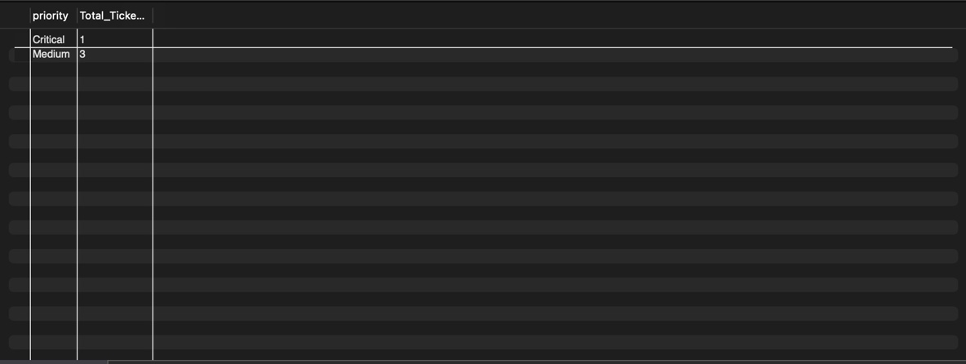
Fig. 3.2.1 Table showing tickets grouped by priority

Question-2: Calculate the average, maximum, and minimum AI confidence scores across all ticket predictions in the system.

SQL Statement-2: SELECT
AVG(confidence_score) AS Average_Score,
MAX(confidence_score) AS Highest_Score,
MIN(confidence_score) AS Lowest_Score
FROM AI_Analysis;

Output-2: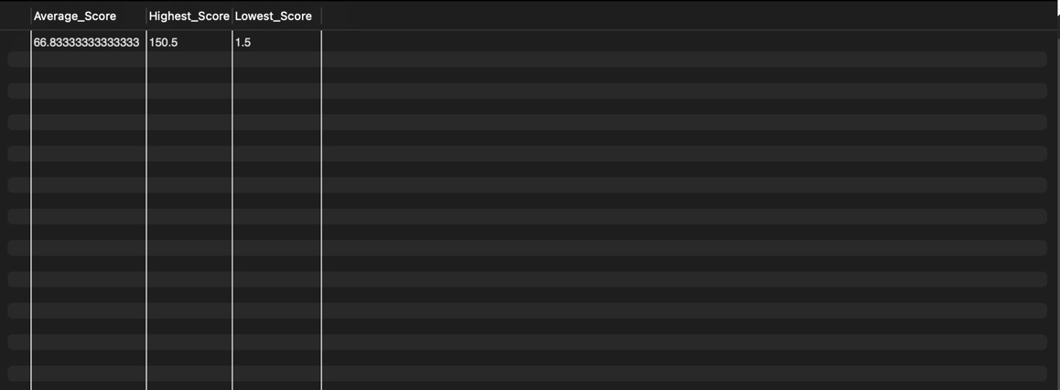
Fig3.2.2 Table showing average, highest and lowest scores

Question-3: Find the total number of tickets assigned to each agent, including agents who currently have zero tickets assigned to them.

SQL Statement-3: SELECT u.username AS Agent_Name, COUNT(t.ticket_id) AS Assigned_Tickets
FROM Users u
LEFT JOIN Tickets t ON u.user_id = t.assigned_agent_id
WHERE u.role = 'Agent'

GROUP BY u.user_id;

Output-3: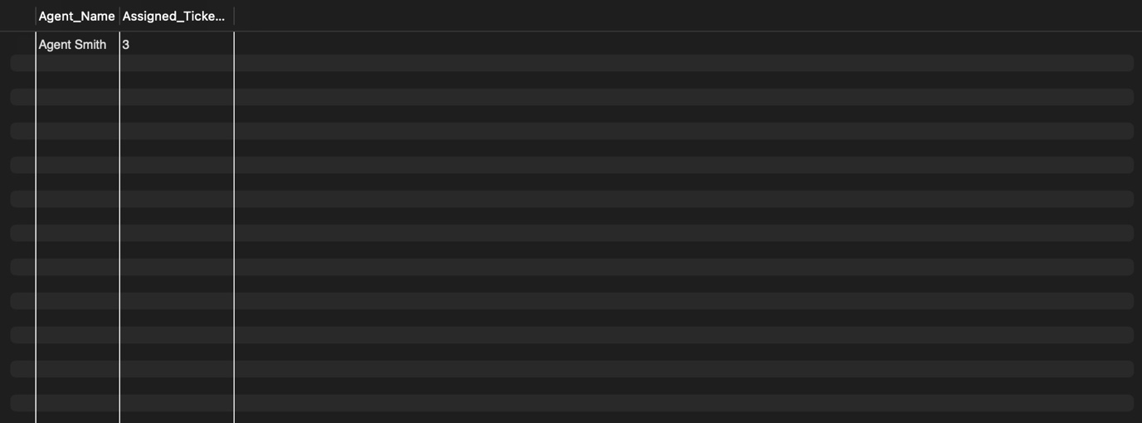
Fig. 3.2.3 Table showing agent and assigned Tickets

  - Complex queries based on Sets

Question: Use a set operation (UNION) to retrieve a single combined list of all unique Admin usernames and Agent usernames from the system.

SQL Statement: SELECT username AS Staff_Members, role FROM Users WHERE role = ‘Admin’
UNION
SELECT username AS Staff_Members, role FROM Users WHERE role = ‘Agent’;

Output: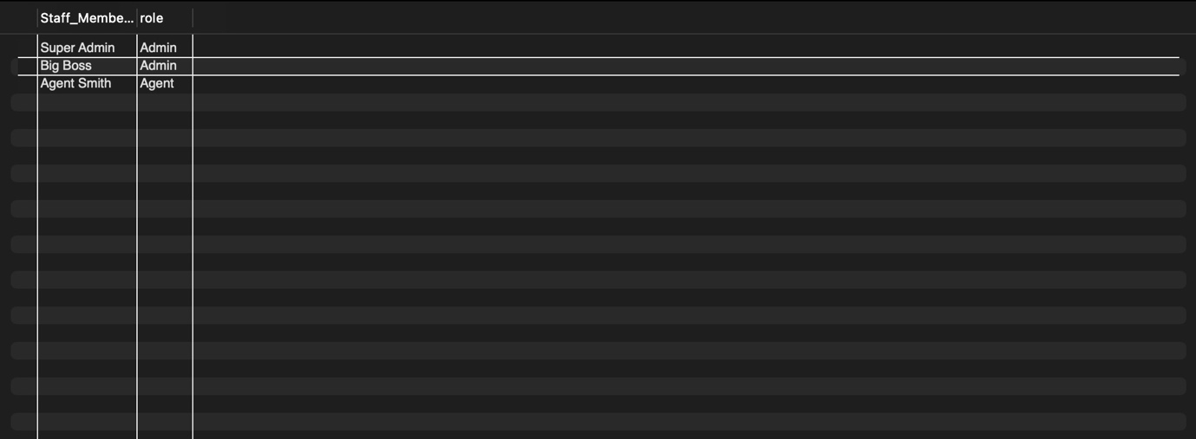
Fig. 3.3.1 table showing staff members and their roles

Question: Retrieve a list of all ticket subjects and all category descriptions into a single column to build a combined text corpus for keyword analysis using UNION ALL.

SQL Statement: SELECT subject AS Text_Data FROM Tickets
UNION ALL
SELECT description AS Text_Data FROM Categories;

Output: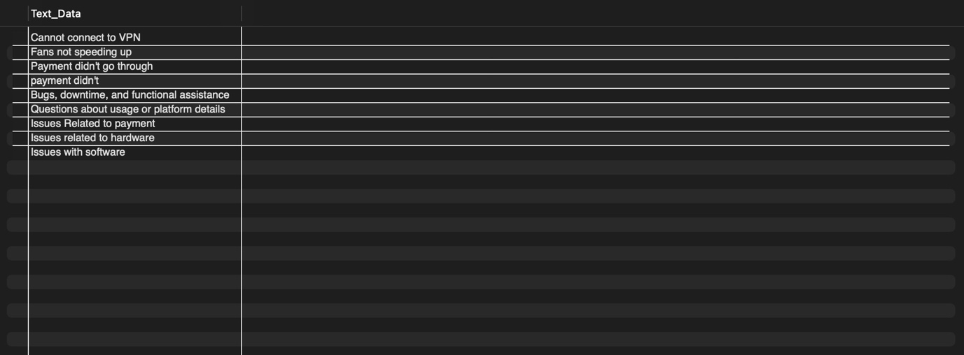
Fig3.3.2 Table showing ticket subjects

Question: Use a set operation to find the IDs of users who act as an 'Agent' but have also submitted a ticket as a customer themselves.

SQL Statement: SELECT user_id, username
FROM Users
WHERE role = 'Agent'
AND user_id IN (SELECT user_id FROM Tickets);

Output:
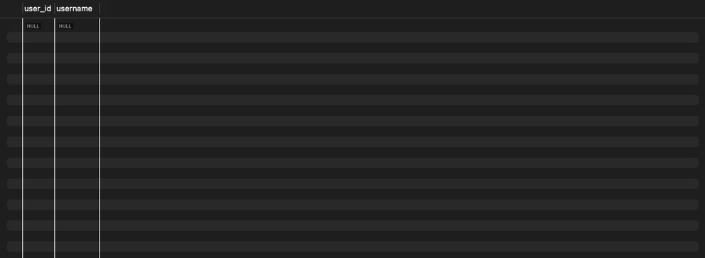
Fig3.3.3 table showing agents who also have submitted tickets as customers

  - Complex queries based on Subqueries

Question: Retrieve the details of all tickets that have an AI confidence score higher than the average confidence score of all predictions.

SQL Statement: SELECT ticket_id, subject, priority
FROM Tickets
WHERE ticket_id IN (
SELECT ticket_id FROM AI_Analysis
WHERE confidence_score > (SELECT AVG(confidence_score) FROM AI_Analysis)
);

Output: 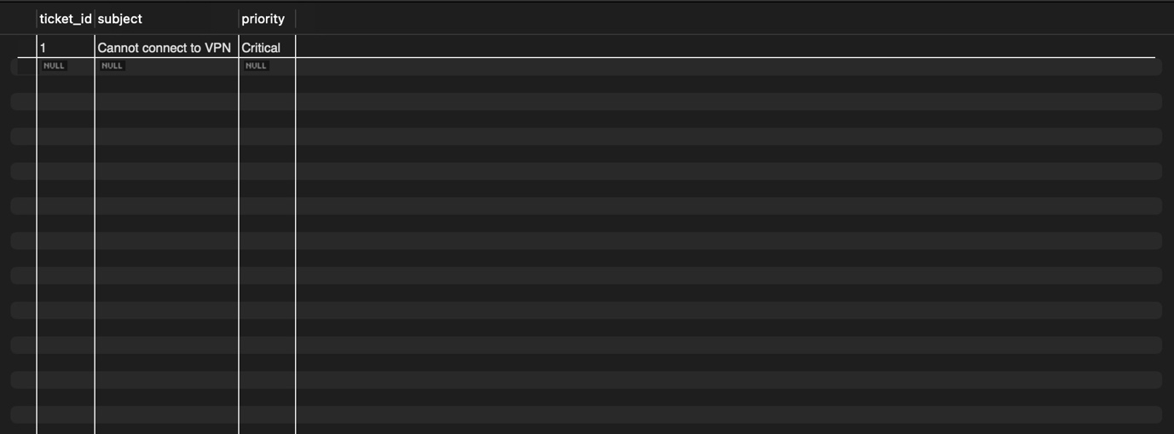
Fig3.4.1 table showing ticket with AI Confidence score higher than average

Question: Find the names of users who have submitted a ticket classified under the ‘Hardware’ category.

SQL Statement:
SELECT username, email
FROM Users
WHERE user_id IN (

SELECT user_id FROM Tickets
WHERE categories_id = (SELECT categories_id FROM Categories WHERE category_name = 'Billing')
);
Output: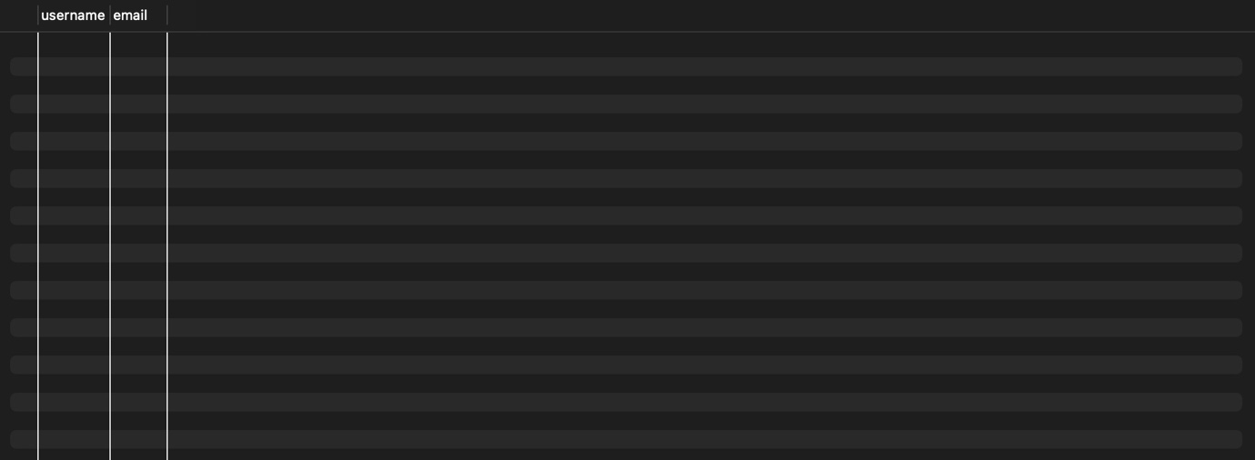
Fig3.4.2 Table showing tickets submitted in billings category

Question: List the names of all categories that currently have no tickets associated with them.

SQL Statement:
SELECT category_name
FROM Categories
WHERE categories_id NOT IN (SELECT DISTINCT categories_id FROM Tickets);

Output: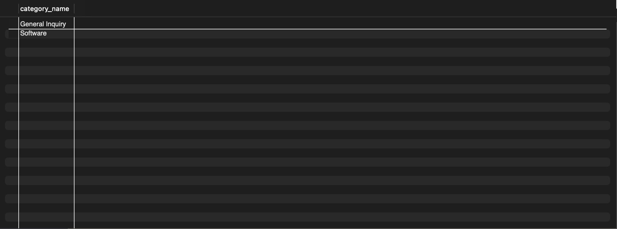
Fig3.4.3 table showing categories under which no tickets are submitted

  - Complex queries based on Joins
Question: Display the Ticket Subject, Customer Name, Category Name, and the assigned Agent's Name for all open tickets.

SQL Statement:
SELECT t.subject, c.username AS Customer, cat.category_name, a.username AS Agent
FROM Tickets t
JOIN Users c ON t.user_id = c.user_id
JOIN Categories cat ON t.categories_id = cat.categories_id
LEFT JOIN Users a ON t.assigned_agent_id = a.user_id
WHERE t.status = 'Open';

Output: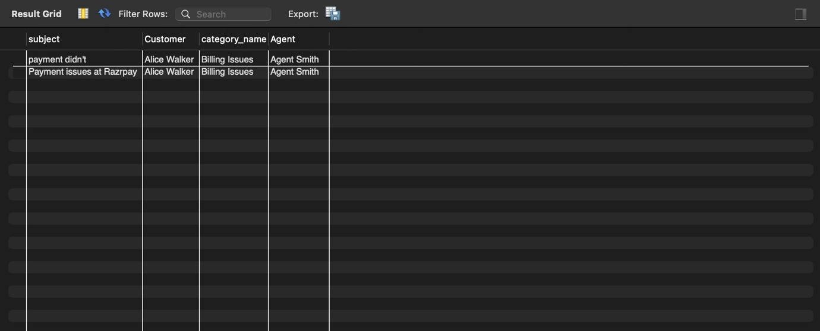
Fig3.5.1 table showing ticket details

Question: Display a complete history of updates (comments) for a specific ticket, including the username of the person who wrote the comment.

SQL Statement:
SELECT t.subject, u.username AS Author, tu.comments, tu.created_at
FROM ticket_updates tu
JOIN Tickets t ON tu.ticket_id = t.ticket_id
JOIN Users u ON tu.user_id = u.user_id
WHERE t.ticket_id = 1
ORDER BY tu.created_at ASC;

Output:
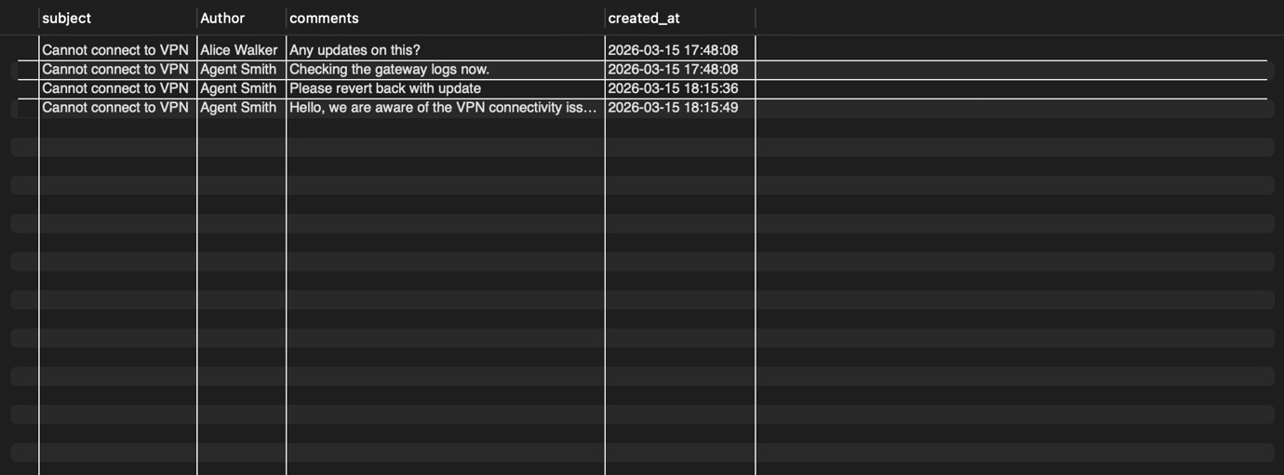
Fig3.5.2 table showing ticket update history

Question: Retrieve all tickets along with their AI prediction feedback, but only for tickets where the AI was more than 90% confident.
SQL-Statement:
SELECT t.ticket_id, t.subject, ai.reasoning, ai.confidence_score
FROM Tickets t
INNER JOIN AI_Analysis ai ON t.ticket_id = ai.ticket_id
WHERE ai.confidence_score > 90.0;

Output:
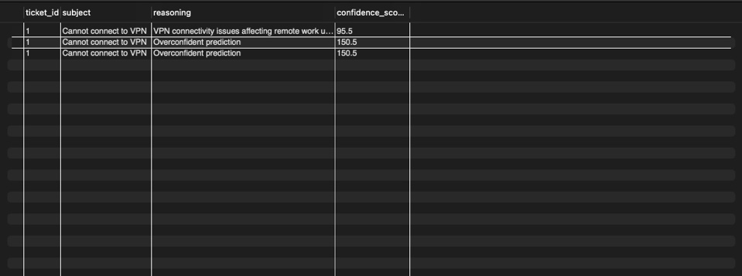
Fig3.5.3 table showing tickets with more than 90 confidence score

  - Complex queries based on views
Question: Create a secure view for the Agent Dashboard that only shows High and Critical priority tickets without exposing user email addresses.

SQL Statement: CREATE VIEW Agent_Dashboard AS
SELECT t.ticket_id, t.subject, t.priority, t.status, c.username AS Customer_Name
FROM Tickets t
JOIN Users c ON t.user_id = c.user_id
WHERE t.priority IN ('High', 'Critical');
SELECT * FROM Agent_Dashboard;

Output: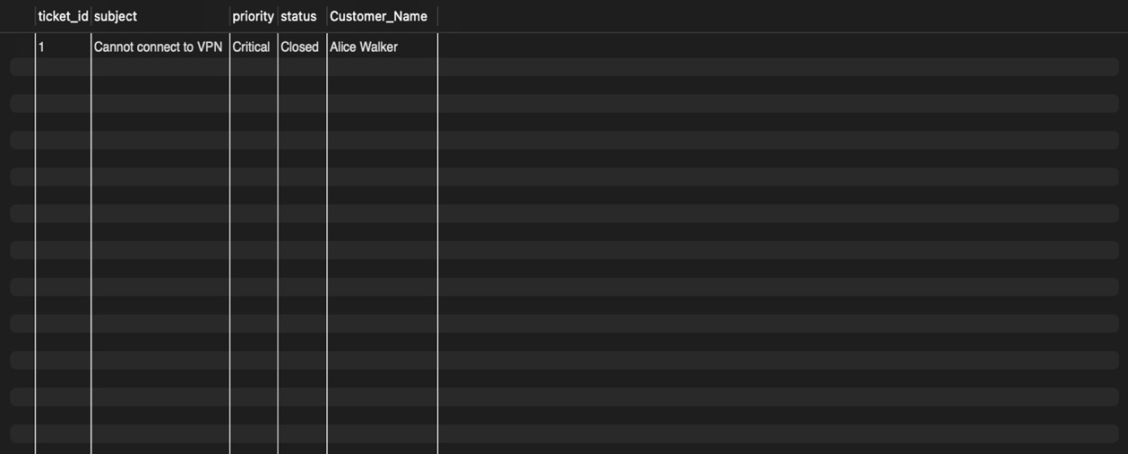
Fig3.6.1 Table showing agent dashboard view

Question: Create a view that summarizes the AI model's performance by showing the average confidence score per ticket category.

SQL Statement:
CREATE VIEW AI_Performance_Summary AS
SELECT c.category_name, AVG(ai.confidence_score) AS Avg_Confidence, COUNT(t.ticket_id) AS Tickets_Analyzed
FROM Categories c
JOIN Tickets t ON c.categories_id = t.categories_id
JOIN AI_Predictions ai ON t.ticket_id = ai.ticket_id
GROUP BY c.category_name;
SELECT * FROM AI_Performance_Summary;

Output: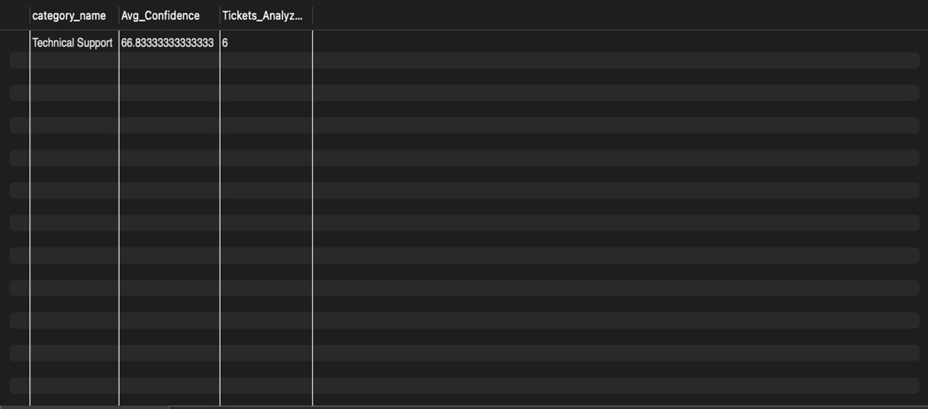
Fig3.6.2 table showing AI performance dashboard

Question: Create a view that acts as an archive, displaying only tickets that have been marked as 'Closed' along with their final resolution timestamps.

SQL Statement: CREATE VIEW Closed_Tickets_Archive AS
SELECT ticket_id, subject, priority, updated_at AS closed_date
FROM Tickets
WHERE status = 'Closed';
SELECT * FROM Closed_Tickets_Archive;

Output: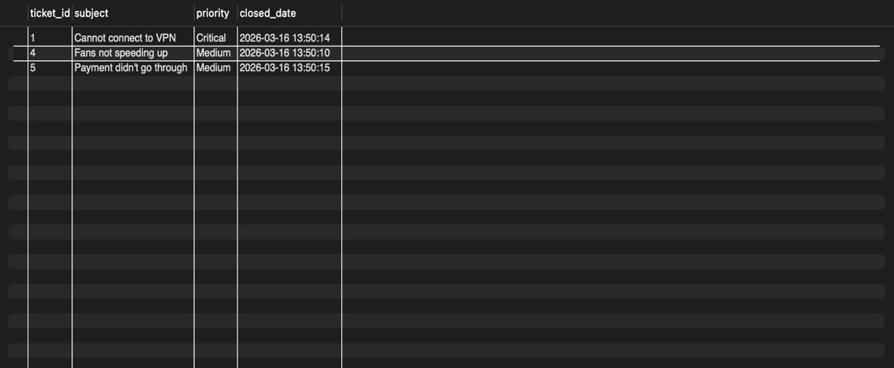
Fig3.6.3 Table showing closed tickets

  - Complex queries based on Triggers
Question: Create a trigger that automatically updates the updated_at timestamp in the Tickets table whenever a new comment is added to ticket_update
SQL Statement:
DELIMITER //
CREATE TRIGGER UpdateTicketTimestamp
AFTER INSERT ON ticket_update
FOR EACH ROW
BEGIN
UPDATE Tickets
SET updated_at = CURRENT_TIMESTAMP
WHERE ticket_id = NEW.ticket_id;
END; //
DELIMITER ;

Output: 0 row(s) affected

Question: Create an audit table and a trigger that logs the status changes of a ticket every time it is updated.

SQL Statement:
CREATE TABLE Ticket_Status_Audit (
audit_id INT AUTO_INCREMENT PRIMARY KEY,
ticket_id INT,

old_status VARCHAR(20),
new_status VARCHAR(20),
changed_at TIMESTAMP DEFAULT CURRENT_TIMESTAMP
);

DELIMITER //
CREATE TRIGGER LogStatusChange
AFTER UPDATE ON Tickets
FOR EACH ROW
BEGIN
IF OLD.status != NEW.status THEN
INSERT INTO Ticket_Status_Audit (ticket_id, old_status, new_status)
VALUES (OLD.ticket_id, OLD.status, NEW.status);
END IF;
END; //
DELIMITER ;
Output: 0 row(s) affected

Question: Create a trigger that automatically inserts an initial automated comment into ticket_update welcoming the user whenever they create a new ticket.
SQL Statement: DELIMITER //
CREATE TRIGGER AutoWelcomeComment
AFTER INSERT ON Tickets

FOR EACH ROW
BEGIN
INSERT INTO ticket_update (ticket_id, user_id, comments, is_internal)
VALUES (NEW.ticket_id, NEW.user_id, 'System: We have received your ticket and the AI is currently classifying it. An agent will be assigned shortly.', FALSE);
END; //
DELIMITER ;
Output: 0 row(s) affected
  - Complex queries based on Cursors
Question: Write a stored procedure using a cursor to iterate through all 'Open' tickets and generate a printed list of their subjects and IDs for a daily report.
SQL Statement: DELIMITER //
CREATE PROCEDURE GenerateOpenTicketReport()
BEGIN
DECLARE done INT DEFAULT FALSE;
DECLARE v_id INT;
DECLARE v_subject VARCHAR(150);
DECLARE ticket_cursor CURSOR FOR SELECT ticket_id, subject FROM Tickets WHERE status = 'Open';
DECLARE CONTINUE HANDLER FOR NOT FOUND SET done = TRUE;
OPEN ticket_cursor;
read_loop: LOOP
FETCH ticket_cursor INTO v_id, v_subject;
IF done THEN
LEAVE read_loop;
END IF;
SELECT CONCAT('Report: Ticket ID ', v_id, ' - ', v_subject) AS Daily_Report;
END LOOP;
CLOSE ticket_cursor;
END; //
DELIMITER ;
CALL GenerateOpenTicketReport();

Output: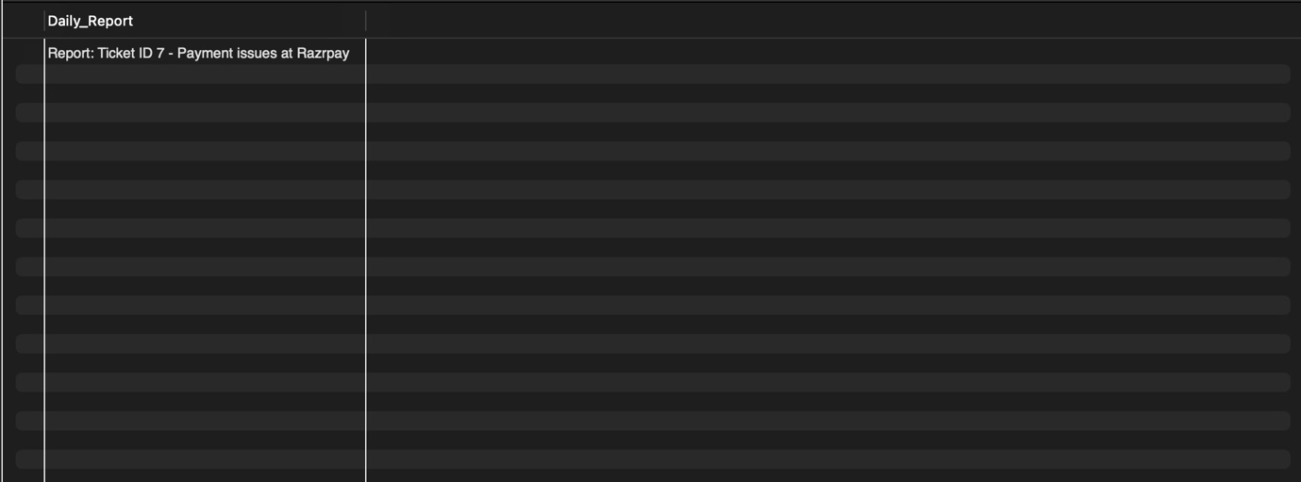
Fig 3.8.1 table showing the result of procedure

Question: Use a cursor within a stored procedure to loop through all agents and count the exact number of internal notes (is_internal = TRUE) they have written across all tickets.
SQL Statement:
DELIMITER //
CREATE PROCEDURE CountInternalAgentNotes()
BEGIN
DECLARE done INT DEFAULT FALSE;
DECLARE v_agent_name VARCHAR(50);
DECLARE v_note_count INT;
DECLARE agent_cursor CURSOR FOR
SELECT u.username, COUNT(tu.update_id)
FROM Users u
JOIN ticket_update tu ON u.user_id = tu.user_id
WHERE u.role = 'Agent' AND tu.is_internal = TRUE
GROUP BY u.username;
DECLARE CONTINUE HANDLER FOR NOT FOUND SET done = TRUE;

OPEN agent_cursor;
read_loop: LOOP
FETCH agent_cursor INTO v_agent_name, v_note_count;
IF done THEN
LEAVE read_loop;
END IF;
SELECT CONCAT('Agent ', v_agent_name, ' has written ', v_note_count, ' internal notes.') AS Audit_Log;
END LOOP;
CLOSE agent_cursor;
END; //
DELIMITER ;
CALL CountInternalAgentNotes();
Output: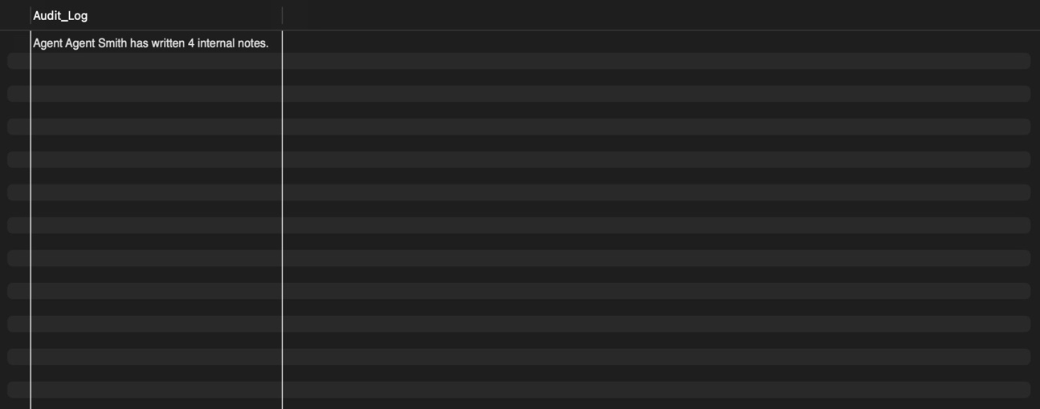
Fig3.8.2 Table showing output of a procedure
Question: Create a stored procedure with a cursor that identifies all AI predictions with a confidence score below 0.70 and outputs a warning flag indicating they require manual review.
SQL Statement: DELIMITER //
CREATE PROCEDURE FlagLowConfidenceAI()
BEGIN
DECLARE done INT DEFAULT FALSE;
DECLARE v_ticket_id INT;
DECLARE v_score FLOAT;
DECLARE ai_cursor CURSOR FOR SELECT ticket_id, confidence_score FROM AI_Analysis WHERE confidence_score < 70.0;
DECLARE CONTINUE HANDLER FOR NOT FOUND SET done = TRUE;

OPEN ai_cursor;
read_loop: LOOP
FETCH ai_cursor INTO v_ticket_id, v_score;
IF done THEN
LEAVE read_loop;
END IF;
SELECT CONCAT('WARNING: Ticket ', v_ticket_id, ' needs manual review. AI Score: ', v_score) AS Review_Alert;
END LOOP;
CLOSE ai_cursor;
END; //
DELIMITER ;
CALL FlagLowConfidenceAI();

Output:
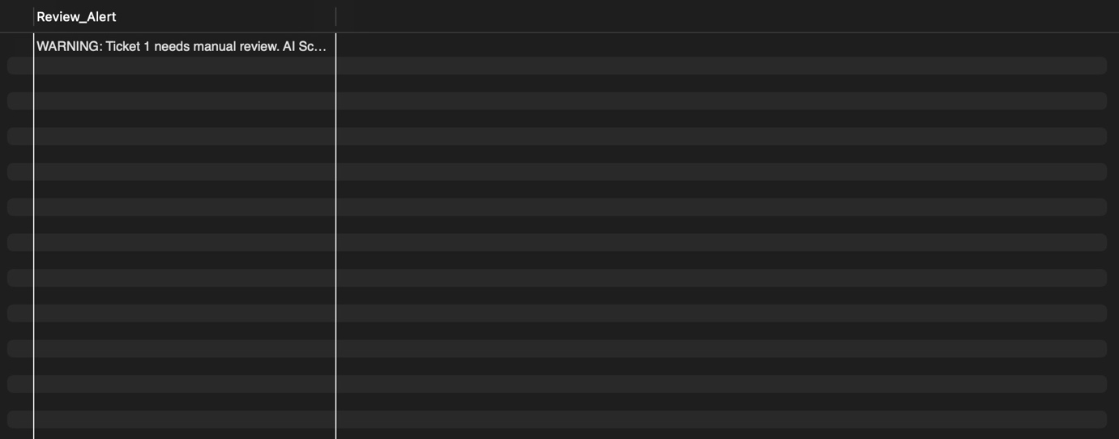
Fig3.8.3 Table showing the number of ticket with less confidence score

CHAPTER 4

ANALYZING THE PITFALLS, IDENTIFYING THE DEPENDENCIES, AND APPLYING NORMALIZATIONS

4.1 Analyse the Pitfalls in Relations
During the initial design phase of the Intelligent Support Ticket System, storing related data together in fewer tables created data anomalies. For example, if a Ticket table also stored the name of the category (e.g., "Billing") and the user's email directly alongside the ticket subject, updating a user's email or changing a category name would require scanning and updating every single ticket they ever submitted. This leads to Update Anomalies, Insertion Anomalies (cannot create a category without a ticket), and Deletion Anomalies (deleting a ticket might delete the only record of a specific user or category). Normalization was applied to separate these entities into Users, Categories, Tickets, Ticket_Updates, and AI_Analysis.

4.2 First Normal Form

4.2.1: Identify Dependency
In 1NF, a table must not contain repeating groups or multi-valued attributes; every column must be atomic. In a support system, a single ticket generates multiple conversational updates over time.
- Dependency Issue: ticket_id determines a multi-valued list of comments.

4.2.2: Apply Normalization to 1NF
To achieve 1NF, the repeating comments attribute is removed from the Tickets table and placed into its own relation, ensuring each row contains only atomic values.
- Table Before 1NF: Support_Ticket_raw (ticket_id, subject, status, comments)
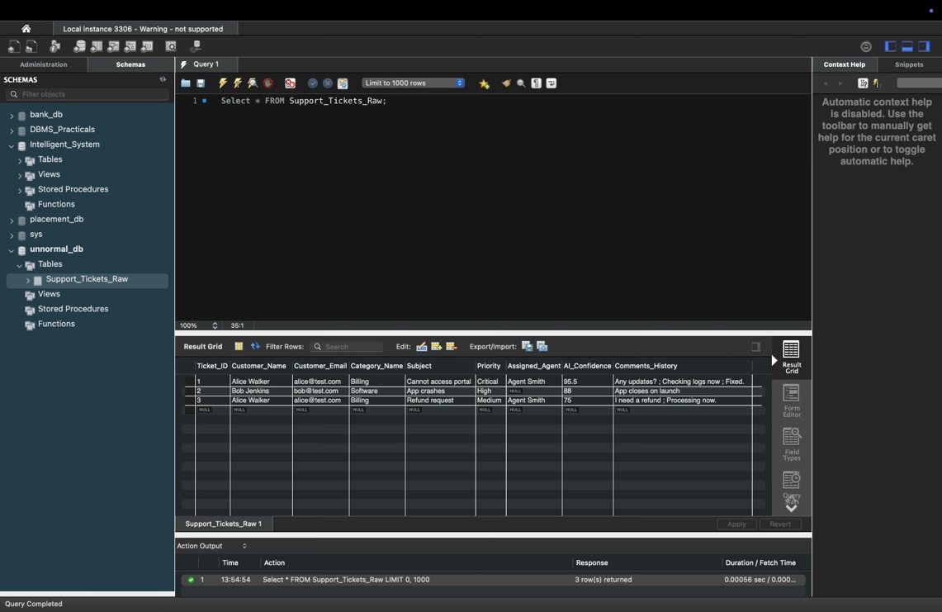
Fig. 4.2.2.1 table before 1NF

- Tables After 1NF: Tickets (ticket_id, subject, status) Ticket_Updates (update_id, ticket_id, comments)

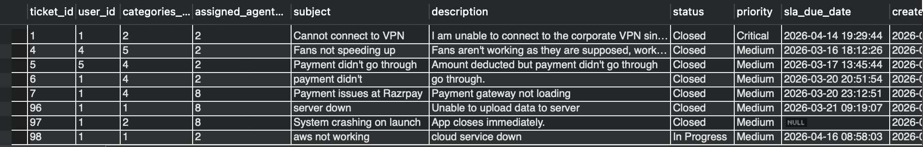
Fig. 4.2.2.2 Table after 1NF

4.3 Second Normal Form

4.3.1: Identify Dependency
A table is in 2NF if it is in 1NF and contains no Partial Dependencies. A partial dependency occurs when a non-prime attribute depends on only part of a composite primary key. If we initially tracked ticket updates using a composite primary key of (ticket_id, user_id) and included the username in that table:
- Partial Dependency: The composite key is (ticket_id, user_id). However, username depends only on user_id, not on ticket_id.

4.3.2: Apply Normalization to 2NF
To achieve 2NF, we remove attributes that depend on only part of the key and place them in a separate table. In the final schema, we also introduced single-column surrogate keys (update_id) to mathematically eliminate partial dependencies.
- Table Before 2NF: Ticket_Updates (ticket_id, user_id, username, comments)
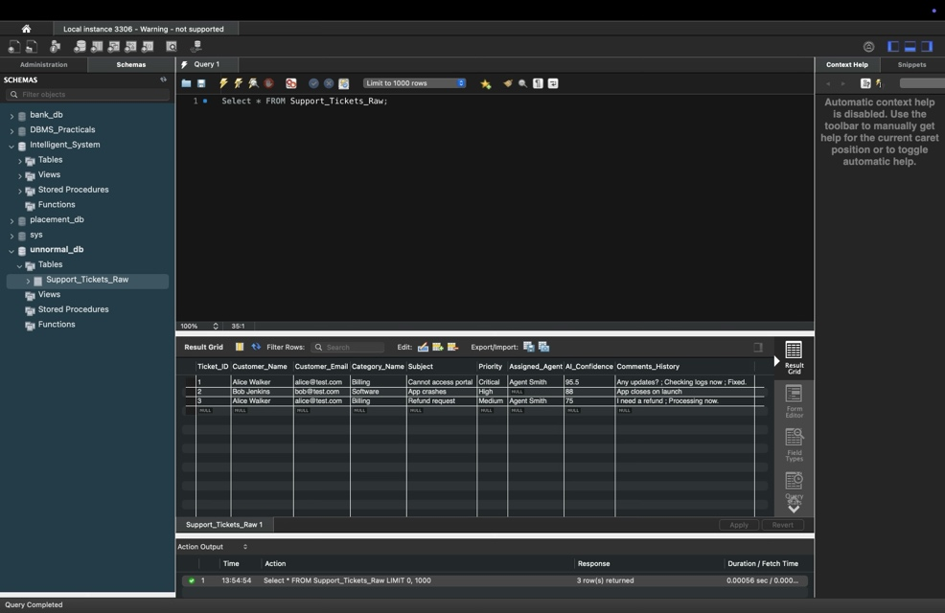
Fig 4.3.2.1 Table before 2NF

- Tables After 2NF: Ticket_Updates (update_id, ticket_id, user_id, comments) Users (user_id, username)
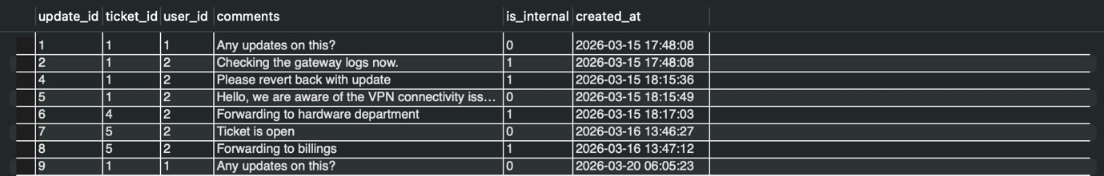
Fig 4.3.2.2 Table after 2NF
4.4 Third Normal Form

4.4.1: Identify Dependency
A table is in 3NF if it is in 2NF and contains no Transitive Dependencies. A transitive dependency occurs when a non-prime attribute depends on another non-prime attribute. Within the ticketing system, tickets are assigned to categories.
- Transitive Dependency: ticket_id -> categories_id, and categories_id -> category_name. Therefore, ticket_id transitively determines category_name.

4.4.2: Apply Normalization to 3NF
To achieve 3NF, we remove the transitive dependency by placing the category details into their own distinct t able.
- Table Before 3NF: Tickets (ticket_id, subject, categories_id, category_name)

Fig. 4.4.2.1 Table Before 3NF
- Tables After 3NF: Tickets (ticket_id, subject, categories_id) Categories (categories_id, category_name)
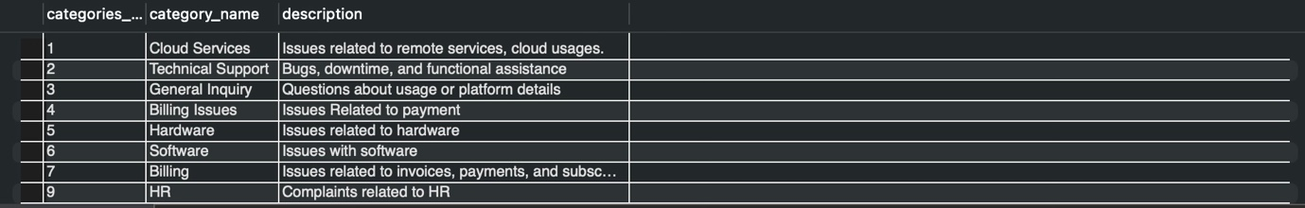
Fig 4.4.2.2 Table after 3NF
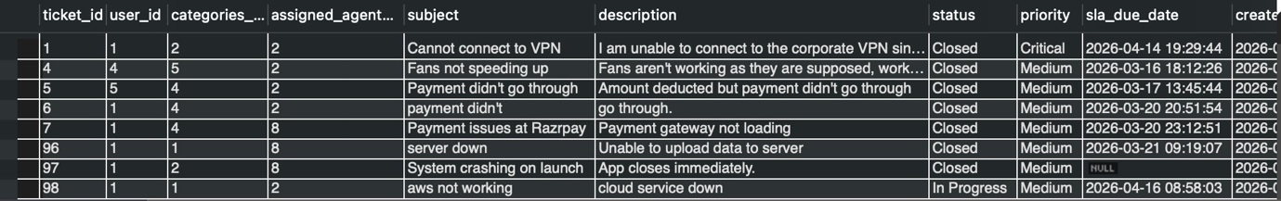
Fig. 4.4.2.3 Table after 3NF

4.5 BCNF
4.5.1: Identify Dependency
BCNF is a stricter version of 3NF. It dictates that for every functional dependency X ->Y, X must be a super key. In our Users table, the primary key is user_id, meaning user_id -> email. However, because no two users can share an email, the reverse functional dependency also exists: email -> user_id.
4.5.2: Apply Normalization to BCNF
To satisfy BCNF, any attribute that acts as a determinant must be a candidate key. We enforce this by applying a UNIQUE constraint to the email column, formally making it a candidate key.
- Table Before BCNF: Users (user_id, username, email)
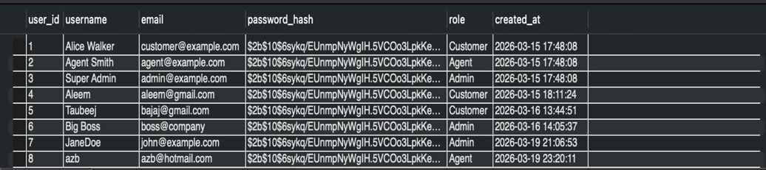
Fig. 4.5.1.1 Table Before 4NF
- Table After BCNF: Users (user_id, username, email [UNIQUE])
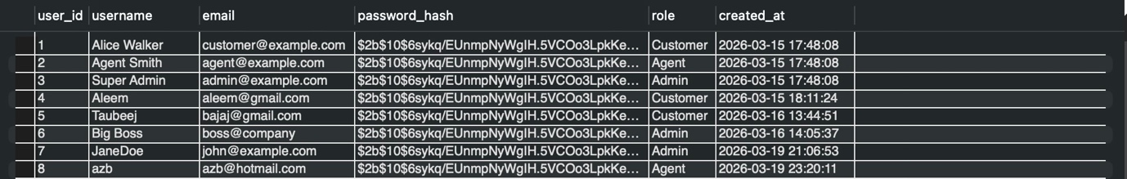
Fig 4.5.1.2 Table after 4NF

4.6 Fourth Normal Form

4.6.1: Identify Dependency
A table is in 4NF if it is in BCNF and contains no Multi-Valued Dependencies (MVD). An MVD occurs when one attribute determines a set of values for another attribute, independent of other attributes (X ->>Y). In this system, a single ticket generates multiple AI reasoning outputs and multiple human chat updates.
- Dependency: ticket_id ->> ai_draft_response AND ticket_id ->> comments. The AI outputs are completely independent of the human updates.

4.6.2: Apply Normalization to 4NF
To resolve this MVD, independent multi-valued facts must not be stored in the same relationship table. They are separated into dedicated tables.
- Table Before 4NF: Ticket_Details (ticket_id,ai_draft_response, comments)

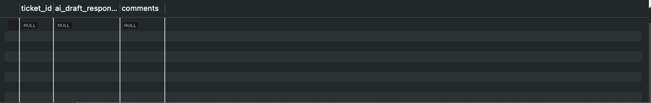
Fig. 4.6.2.1 Table Before 4NF

- Tables After 4NF: Tickets (ticket_id, subject) AI_Analysis (analysis_id, ticket_id, ai_draft_response) Ticket_Updates (update_id, ticket_id, comments)

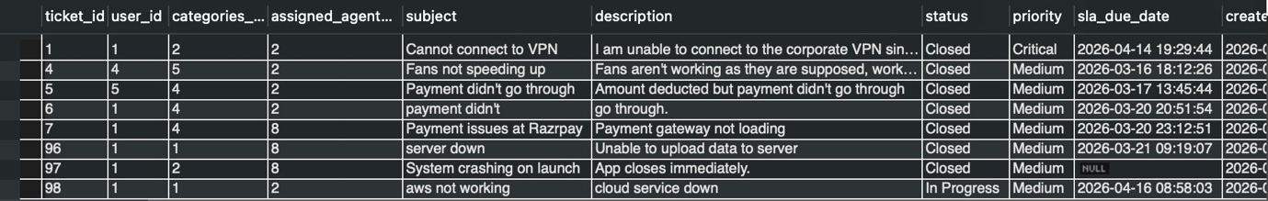
Fig. 4.6.2.2 Table After 4

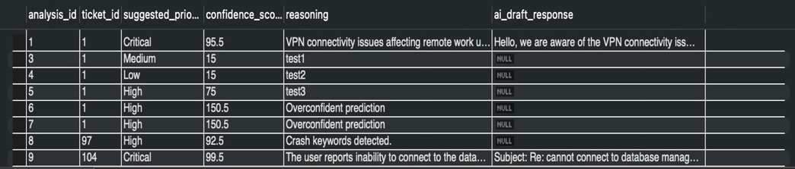
Fig 4.6.2.3 Table After 4NF

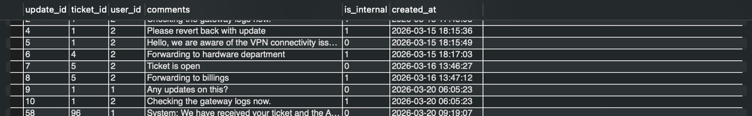
Fig. 4.6.2.4 Table After 4NF

CHAPTER 5
IMPLEMENTATION OF CONCURRENCY CONTROL AND RECOVERY MECHANISMS

  - Introduction to Transaction

    - Properties

- Atomicity → All operations succeed or non
- Consistency → Database remains valid
- Isolation → No interference between transactions
- Durability → Changes persist after commit

    - States

- Active
- Partially Committed
- Commimtted
- Failed
- Aborted

  - Transaction Control Language (TCL)

5.2.1 Save point
- Progress can be restored until this point

5.2.2 Commit
- Save Changes

5.2.3 Rollback
- Undo Changes

5.3 create 5 transactions for your project and execute
5.3.1 Transaction 1: Agent assigns a ticket but rolls back an accidental internal note.
START TRANSACTION;
-- Step 1: Agent takes ownership of the ticket
UPDATE Tickets SET assigned_agent_id = 2, status = 'In Progress' WHERE ticket_id = 6;

-- Step 2: Set a savepoint
SAVEPOINT agent_assigned;

-- Step 3: Agent accidentally posts an internal note
INSERT INTO Ticket_Updates (ticket_id, user_id, comments, is_internal)
VALUES (6, 2, 'Looks like a user error, checking logs.', TRUE);

-- Step 4: Agent realizes mistake, rolls back to savepoint
ROLLBACK TO agent_assigned;

-- Step 5: Agent posts the correct public comment
INSERT INTO Ticket_Updates (ticket_id, user_id, comments, is_internal)
VALUES (6, 2, 'I am looking into your payment issue right now.', FALSE);

-- Step 6: Commit all changes safely
COMMIT;
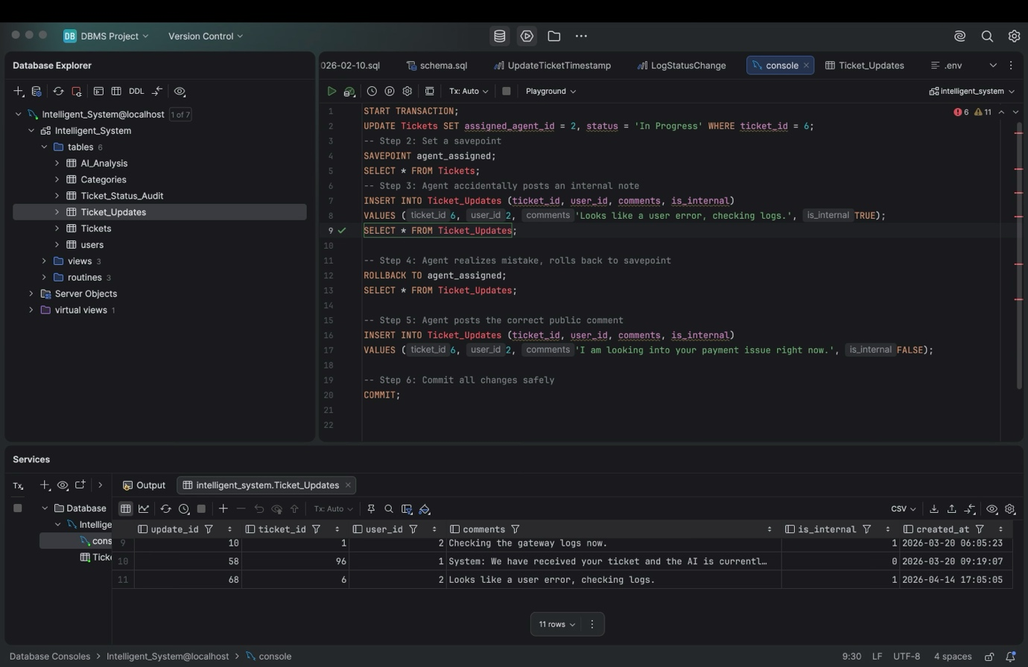
Fig. 5.3.1.1 Before Transaction-1
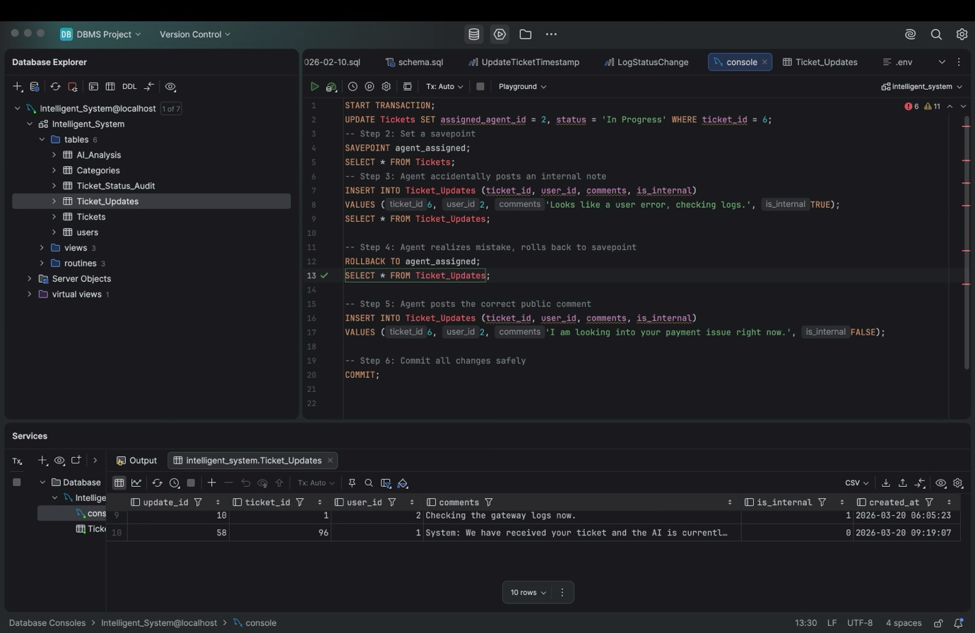
Fig. 5.3.1.2 RollBack 1

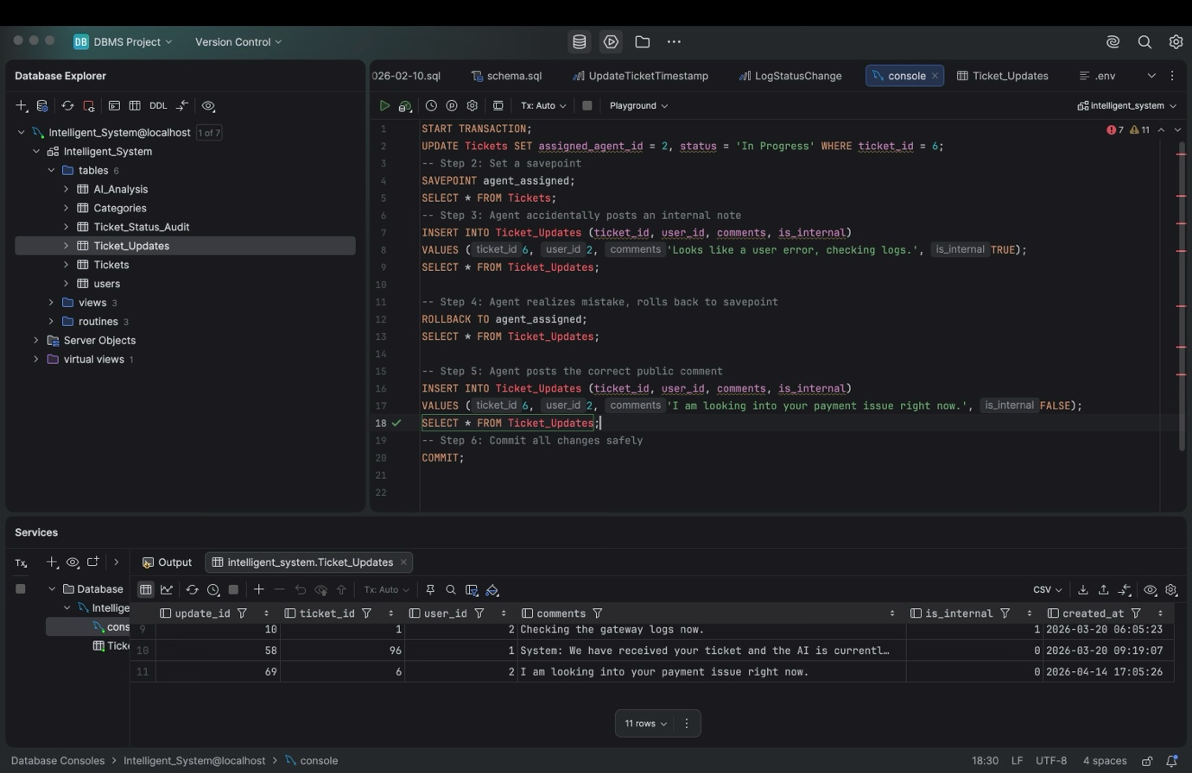
Fig. 5.3.1.1 Commit

5.3.2
Transaction 2:
Administrator attempts to delete a category.
START TRANSACTION;
-- Step 1: Set a savepoint before doing anything destructive
SAVEPOINT before_delete;

-- Step 2: Attempt to delete the General Inquiry category
DELETE FROM Categories WHERE category_name = 'General Inquiry';

-- Step 3: Admin realizes this is dangerous and aborts the operation
ROLLBACK TO before_delete;

-- Step 4: Commit to close the transaction safely with no changes
COMMIT;

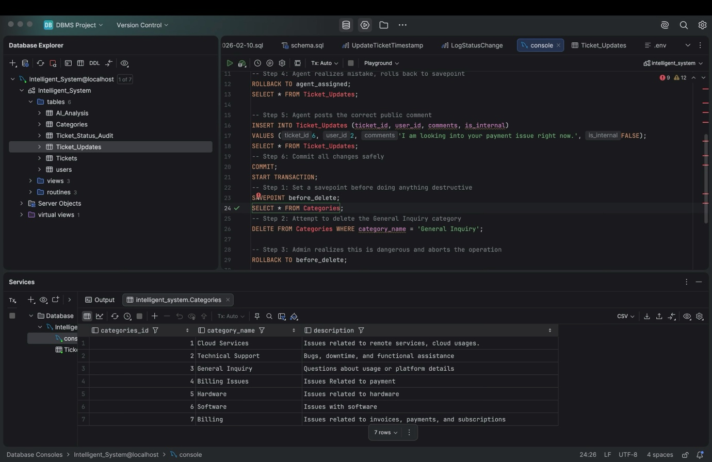
Fig. 5.3.2.1 Before Deleting

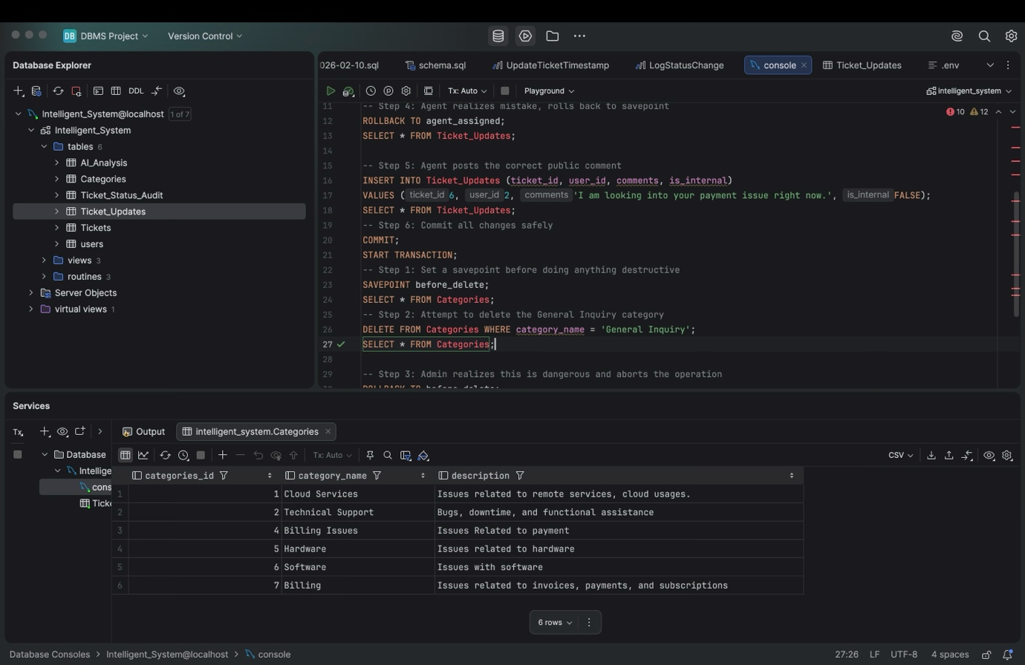
Fig. 5.3.2.2 After Deleting

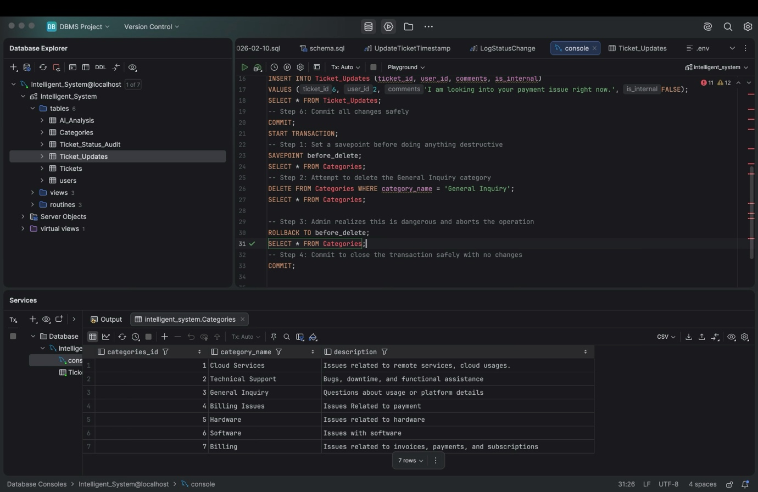
Fig5.3.2.3 After Rollback

5.3.3
Transaction 3:
Bulk updating SLA timelines.
START TRANSACTION;
-- Step 1: Tighten the SLA for Critical tickets by 2 hours
UPDATE Tickets
SET sla_due_date = DATE_ADD(NOW(), INTERVAL 2 HOUR)
WHERE priority = 'Critical' AND status = 'Open';

-- Step 2: Set a savepoint
SAVEPOINT critical_sla_updated;

-- Step 3: Update High priority tickets
UPDATE Tickets
SET sla_due_date = DATE_ADD(NOW(), INTERVAL 12 HOUR)
WHERE priority = 'High' AND status = 'Open';

-- Step 4: Commit all changes
COMMIT;
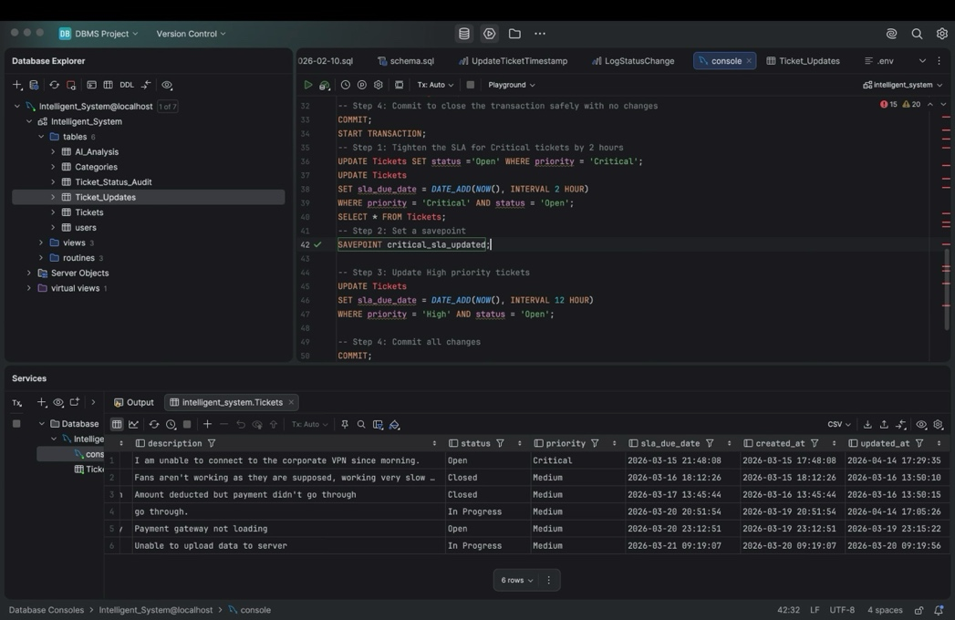
Fig. 5.3.3.1 Before Updating the SLA timeline
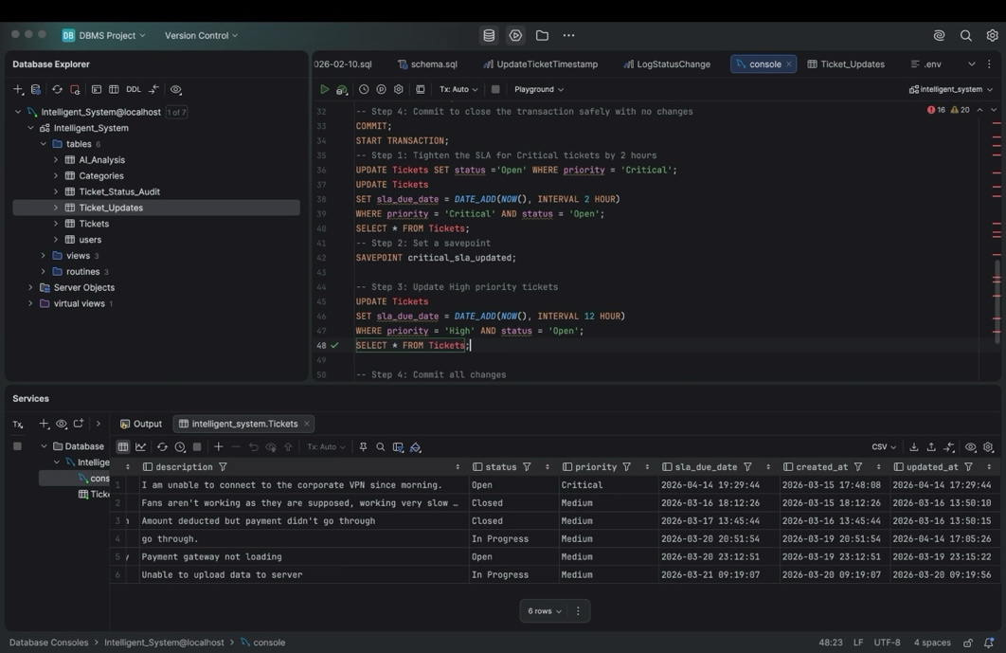
Fig 5.3.3.2 After Updating the SLA timeline

5.3.4
Transaction 4:
Ticket creation coupled with AI Analysis.
START TRANSACTION;
-- Step 1: Customer creates a new ticket
INSERT INTO Tickets (user_id, categories_id, subject, description)
VALUES (1, 2, 'System crashing on launch', 'App closes immediately.');

-- Step 2: Create a savepoint
SAVEPOINT ticket_created;

-- Step 3: System inserts the corresponding AI prediction for the new ticket
INSERT INTO AI_Analysis (ticket_id, suggested_priority, confidence_score, reasoning)
VALUES (LAST_INSERT_ID(), 'High', 92.5, 'Crash keywords detected.');

-- Step 4: Commit both operations together
COMMIT;
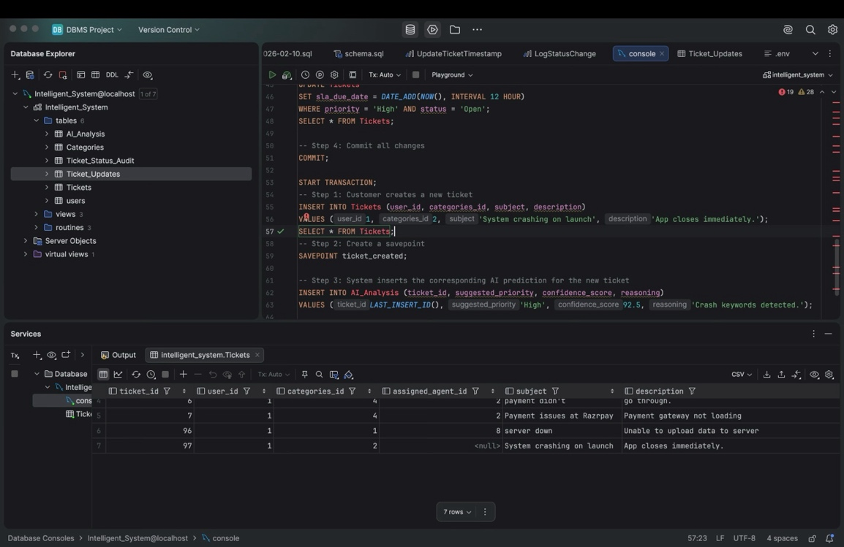
Fig. 5.3.4.1 After Creating a ticket

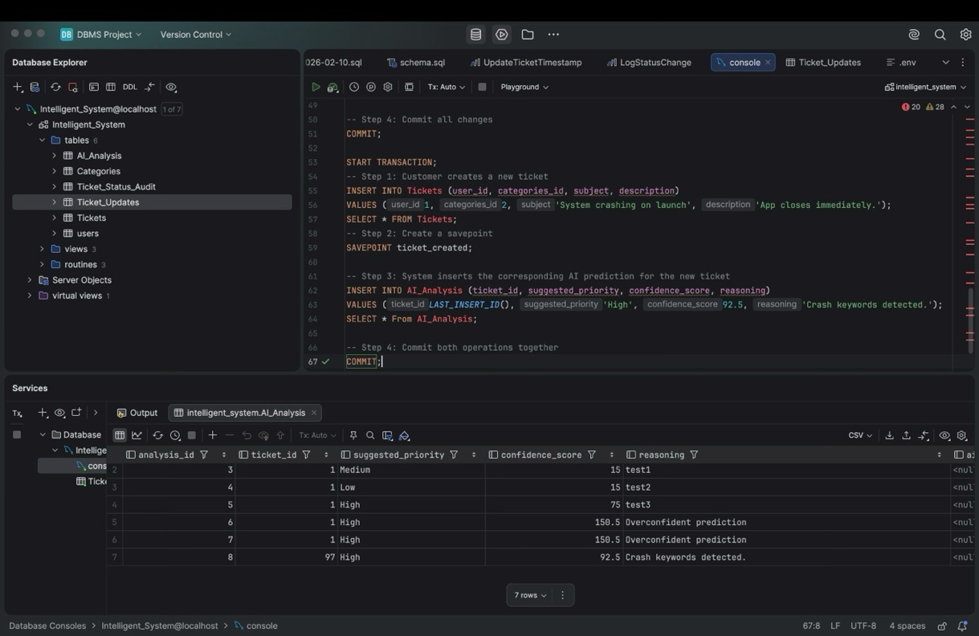
Fig. 5.3.4.2 After Commiting

5.3.5
Transaction 5:

Agent accidentally closes a ticket prematurely.

START TRANSACTION;
-- Step 1: Agent resolves the ticket
UPDATE Tickets SET status = 'Resolved' WHERE ticket_id = 4;

-- Step 2: Agent adds a comment
INSERT INTO Ticket_Updates (ticket_id, user_id, comments, is_internal)
VALUES (4, 2, 'Issue fixed via patch.', FALSE);

-- Step 3: Agent accidentally marks it as Closed
UPDATE Tickets SET status = 'Closed' WHERE ticket_id = 4;

-- Step 4: Realizing the breach of protocol, they rollback the entire transaction
ROLLBACK;

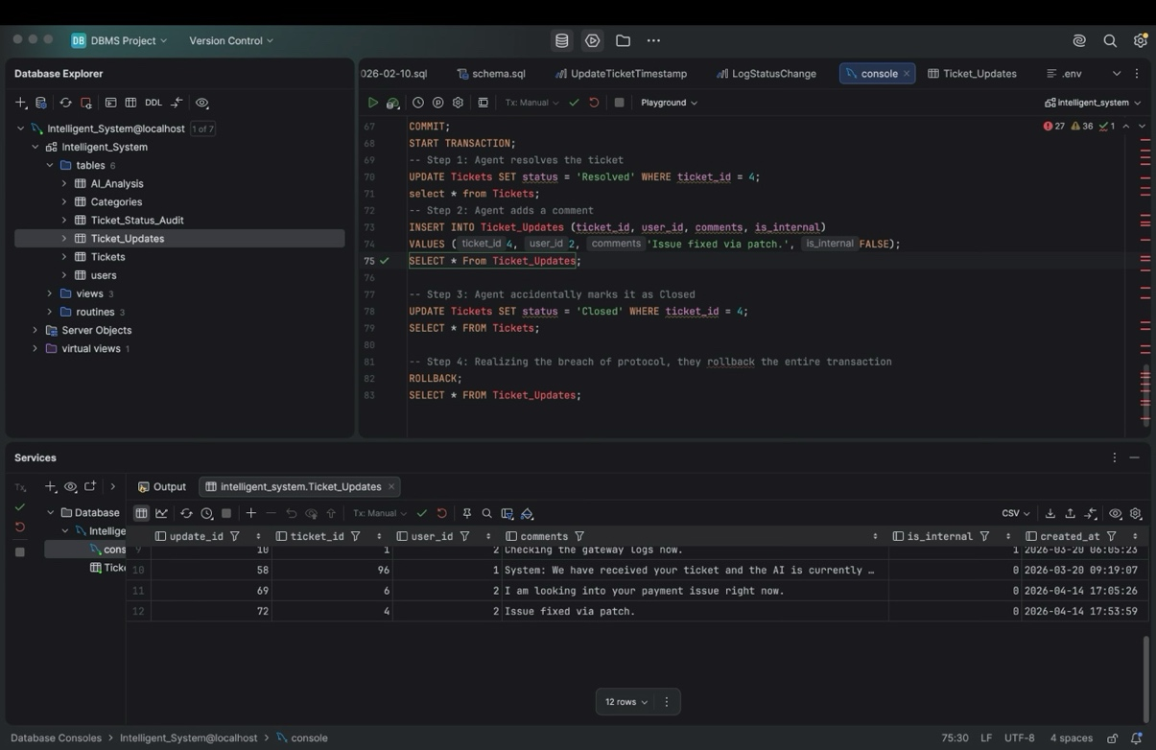
Fig. 5.3.5.1 after closing ticket
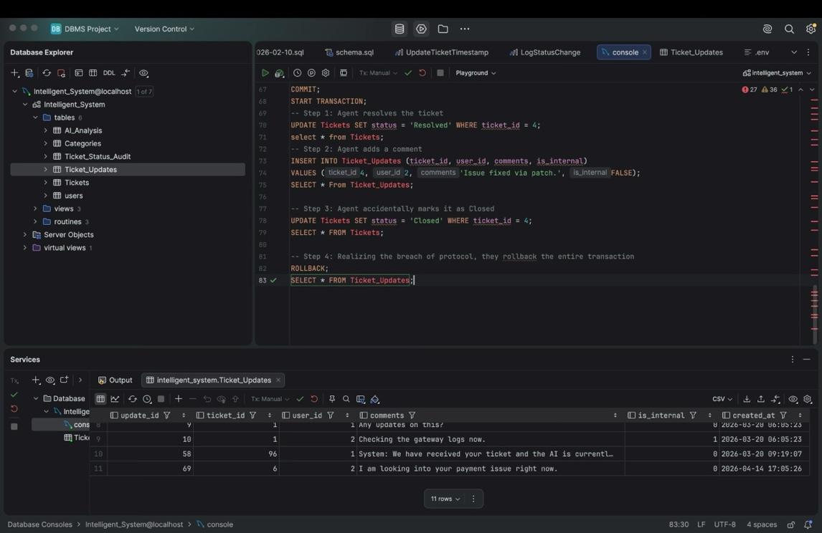
Fig. 5.3.5.2 after rolling back

5.4Concurrency control
5.4.1 Concurrency control Algorithms
5.4.1 Locking commands
a. Row-Level Locking – SELECT ... FOR UPDATE
b. Table-Level Locking – LOCK TABLE
Lock Modes
Lock Mode | Description
ROW SHARE | Allows concurrent access; prevents other sessions from locking the table exclusively.
ROW EXCLUSIVE | Prevents other sessions from locking in share mode. Used by default for DML.
SHARE | Allows queries but not updates or deletes.
SHARE ROW EXCLUSIVE | A mix; more restrictive than SHARE.
EXCLUSIVE | Prevents all other access — full table lock.

c. COMMIT – Release All Locks
d. ROLLBACK – Undo Changes & Release Lock

5.4.2 Example

In our system, Administrators are responsible for routing incoming tickets to the appropriate Agents. However, if multiple Administrators are managing the queue during a high-volume period, a race condition can occur. Two Admins might view the exact same 'Open' ticket and attempt to assign it to two different Agents at the exact same millisecond.
To prevent this data inconsistency and avoid confusing the agents, the IntelliDesk system utilizes Row-Level Locking (SELECT ... FOR UPDATE).

Administrator 1 decides to assign Ticket ID 7 to Agent Smith. The backend executes the following transaction:

START TRANSACTION;

-- Administrator 1 locks the specific ticket row so no one else can read/write it
SELECT assigned_agent_id FROM Tickets
WHERE ticket_id = 7
FOR UPDATE;

-- The application logic checks if assigned_agent_id is still NULL.
-- Since it is, Administrator 1 safely updates the record:
UPDATE Tickets
SET assigned_agent_id = 2, status = 'In Progress'
WHERE ticket_id = 7;

COMMIT; -- The lock is released here

How it prevents the conflict:
If Administrator 2 attempts to assign Ticket ID 7 to a different agent while Administrator 1's transaction is running, Administrator 2's database query will be temporarily paused by the EXCLUSIVE ROW LOCK.
Once Administrator 1 commits their changes and the lock releases, Administrator 2's initial SELECT query will finally execute. However, it will now return assigned_agent_id = 2 instead of NULL. The backend application will see that the ticket is already assigned and safely abort Administrator 2's transaction, alerting them that the ticket was just routed by another Admin.

CHAPTER 6
FRONT-END AND BACK-END CODE OF Intelligent Support Ticket System

6.1 Front–End Module codes
The front-end of the Intelligent Support Ticket System is developed using React.js and styled with Tailwind CSS to ensure a responsive, accessible, and high-contrast user interface. The architecture utilizes strict Role-Based Access Control (RBAC) to render different dashboards based on the user's authentication token.
Below is a core snippet from the TicketDetail.jsx component, which renders the dynamic conversation thread and the "AI Agent Copilot" sidebar for staff members. It conditionally displays the AI's confidence score, suggested priority, and reasoning engine:
// Snippet from TicketDetail.jsx
{isAgentOrAdmin && (
<div className="space-y-6">
<div className="glass-panel p-6 border-pink-500/30 overflow-hidden relative">
<h3 className="relative z-10 flex items-center gap-2 text-pink-400 font-bold text-lg mb-4 border-b border-white/10 pb-3">
<BrainCircuit size={20} /> AI Agent Copilot
</h3>
<div className="relative z-10 space-y-5">
<div>
<div className="flex justify-between text-xs font-bold uppercase tracking-wider text-slate-400 mb-2">
<span>Confidence Score</span>
<span className="text-pink-400">

{ticket.confidence_score ? (ticket.confidence_score * 1).toFixed(1) : '0'}%
</span>
</div>
{/* Visual Progress Bar for AI Confidence */}
<div className="w-full bg-white/10 rounded-full h-2 overflow-hidden border border-white/5">
<div className="bg-gradient-to-r from-pink-500 to-purple-500 h-2 rounded-full"
style={{ width: `${ticket.confidence_score || 0}%` }}>
</div>
</div>
</div>
<div className="bg-black/30 p-4 rounded-xl border border-white/10">
<span className="block text-xs uppercase font-bold text-slate-500 mb-1">AI Reasoning Engine</span>
<p className="text-sm font-mono text-pink-200/80 leading-relaxed bg-black/40 p-3 rounded-lg border border-pink-500/20 mt-2">
{ticket.reasoning || "AI agent has not analyzed this payload yet. Standing by..."}
</p>
</div>
</div>
</div>
</div>

6.2 Database connectivity
The back-end is powered by Node.js and Express.js, utilizing the mysql2 connection pool to handle concurrent database queries. The core intelligence of the system lies in the ticket creation route.
When a user submits a ticket, the back-end intercepts the payload, securely connects to the Google Gemini API (gemini-2.5-flash), generates a structured JSON triage response, and wraps the entire database insertion (Ticket, AI Analysis, and Welcome Comment) within an ACID-compliant SQL Transaction.
// Snippet from backend/routes/tickets.js
const express = require('express');
const router = express.Router();
const db = require('../config/db'); // MySQL Connection Pool
const { GoogleGenAI } = require('@google/genai');
const ai = new GoogleGenAI({ apiKey: process.env.GEMINI_API_KEY });

// Create new ticket and trigger AI Triage
router.post('/', async (req, res) => {
const { user_id, categories_id, subject, description } = req.body;
let connection;
try {
connection = await db.getConnection();
await connection.beginTransaction();

// 1. Call Gemini API for Triage
const prompt = `You are an expert IT support triage agent. Analyze the following support ticket... Return ONLY a valid JSON object with: suggested_priority, confidence_score, reasoning, and ai_draft_response.`;

const aiResponse = await ai.models.generateContent({
model: 'gemini-2.5-flash',
contents: `Subject: ${subject}\nDescription: ${description}`,
config: { responseMimeType: "application/json" }
});
const aiResult = JSON.parse(aiResponse.text);

// 2. Insert Ticket
const [ticketResult] = await connection.query(
'INSERT INTO Tickets (user_id, categories_id, subject, description, status, priority, sla_due_date) VALUES (?, ?, ?, ?, ?, ?, DATE_ADD(NOW(), INTERVAL 24 HOUR))',
[user_id, categories_id, subject, description, 'Open', aiResult.suggested_priority]
);

// 3. Insert AI Analysis into related table
await connection.query(
'INSERT INTO Ai_Analysis (ticket_id, confidence_score, reasoning, ai_draft_response, suggested_priority) VALUES (?, ?, ?, ?, ?)',
[ticketResult.insertId, aiResult.confidence_score, aiResult.reasoning, aiResult.ai_draft_response, aiResult.suggested_priority]
);

await connection.commit();
res.status(201).json({ message: 'Ticket created & triaged successfully' });
} catch (err) {
if (connection) await connection.rollback();
res.status(500).json({ message: 'Server error during transaction' });
} finally {
if (connection) connection.release();
}
});

CHAPTER 7
RESULTS AND DISCUSSIONS

7.1 Screenshots of front-end
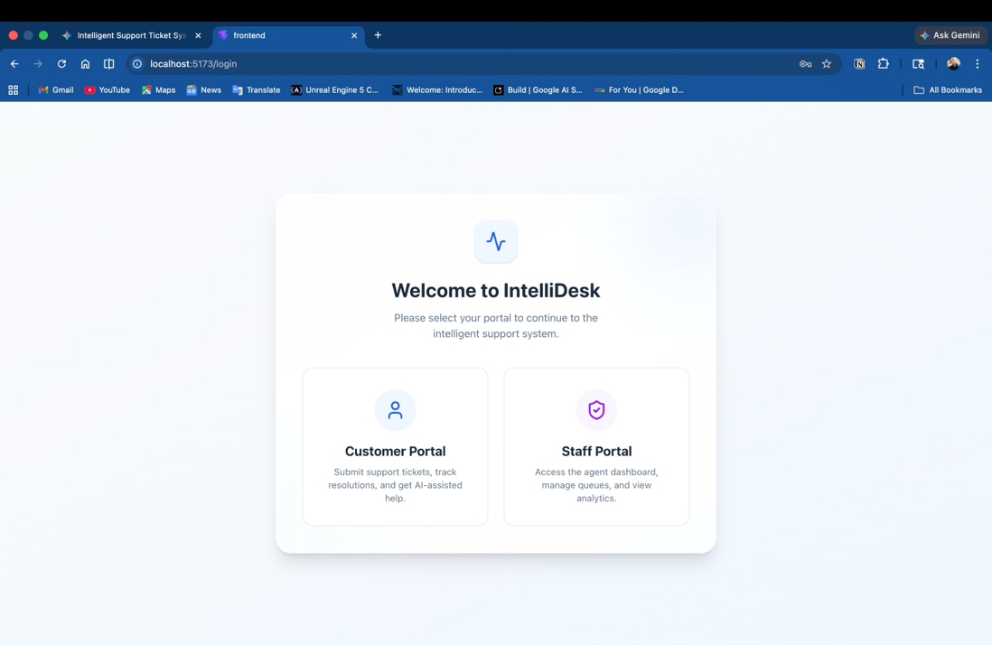
Fig. 7.1.1 Login Screen of IntelliDesk
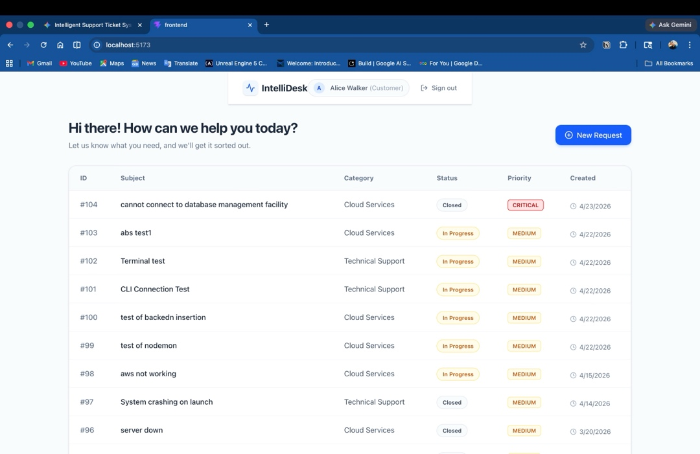
Fig. 7.1.2 Customer Dashboard
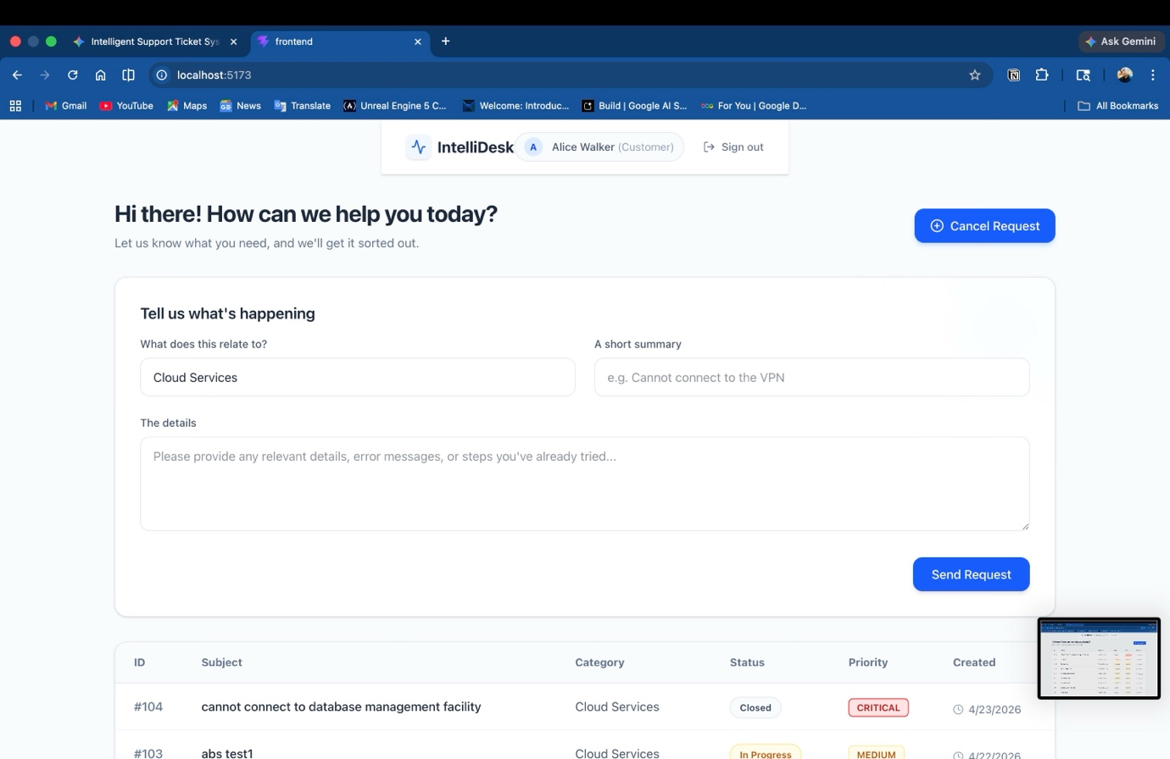
Fig. 7.1.3 Complaint Submission

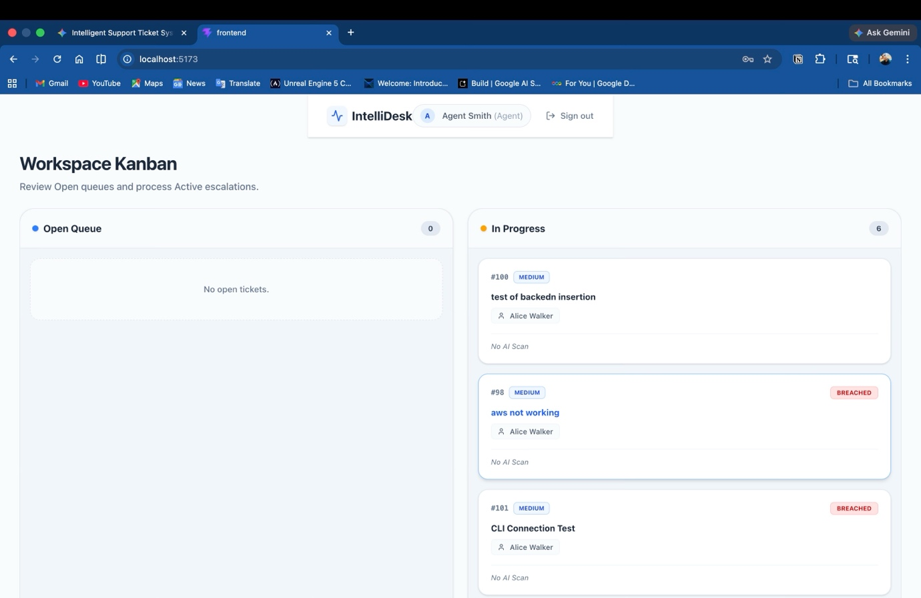
Fig. 7.1.4 Agent Workspace
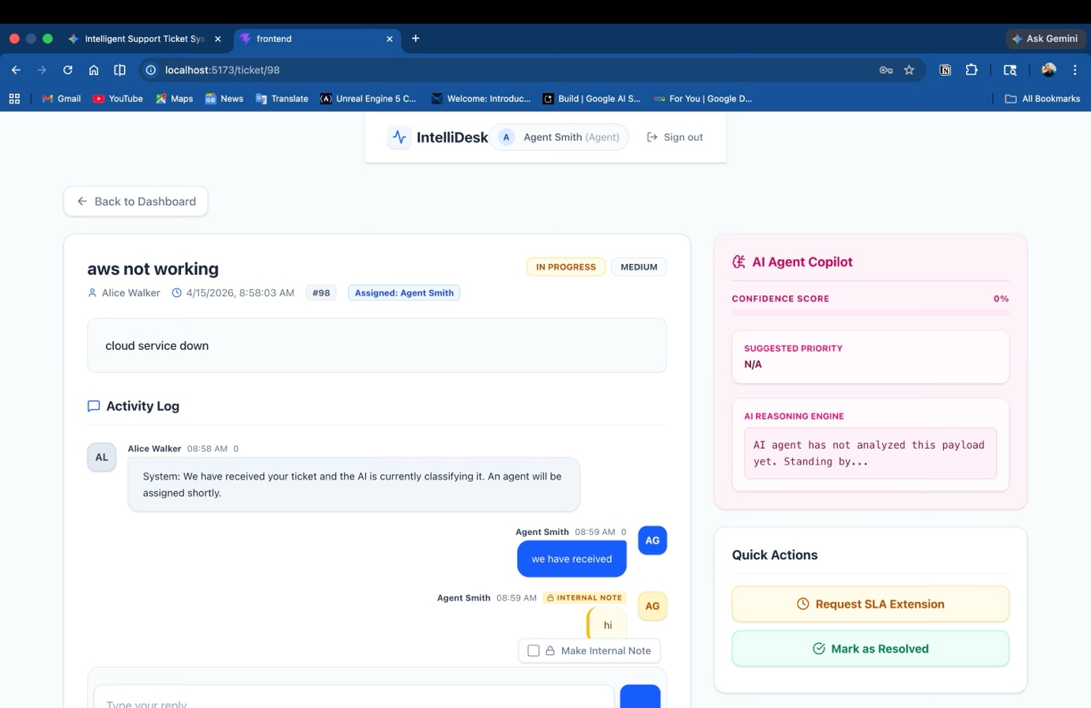
Fig. 7.1.5 Ticket view (Agent Side)

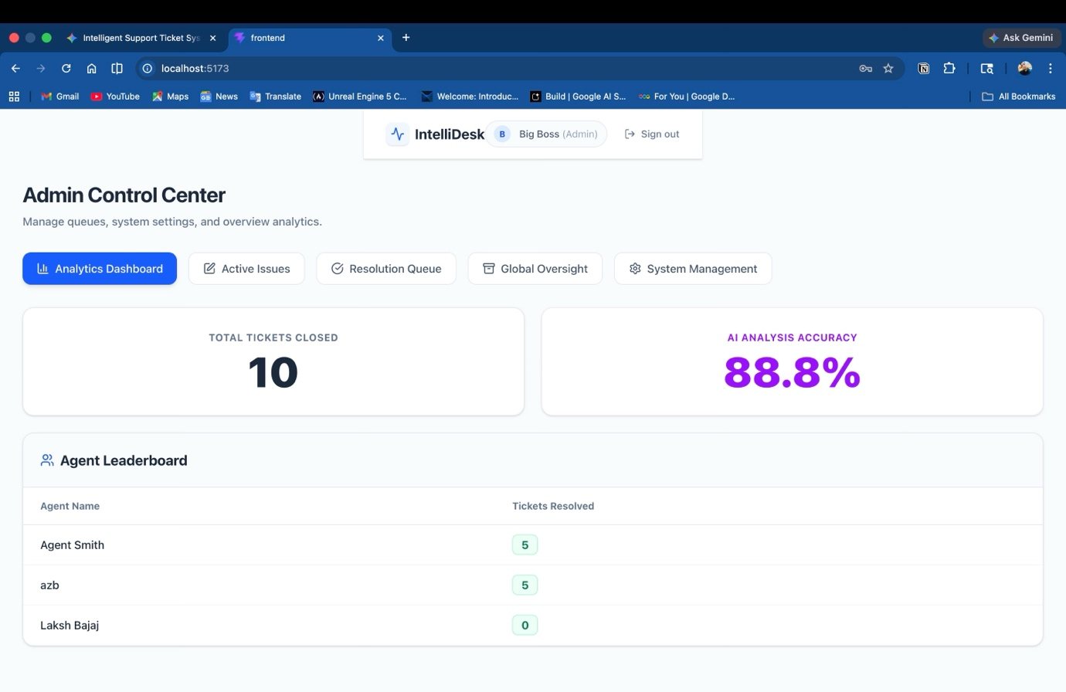
Fig. 7.1.6 Administrator Control Centre and Agent Performance Dashboard

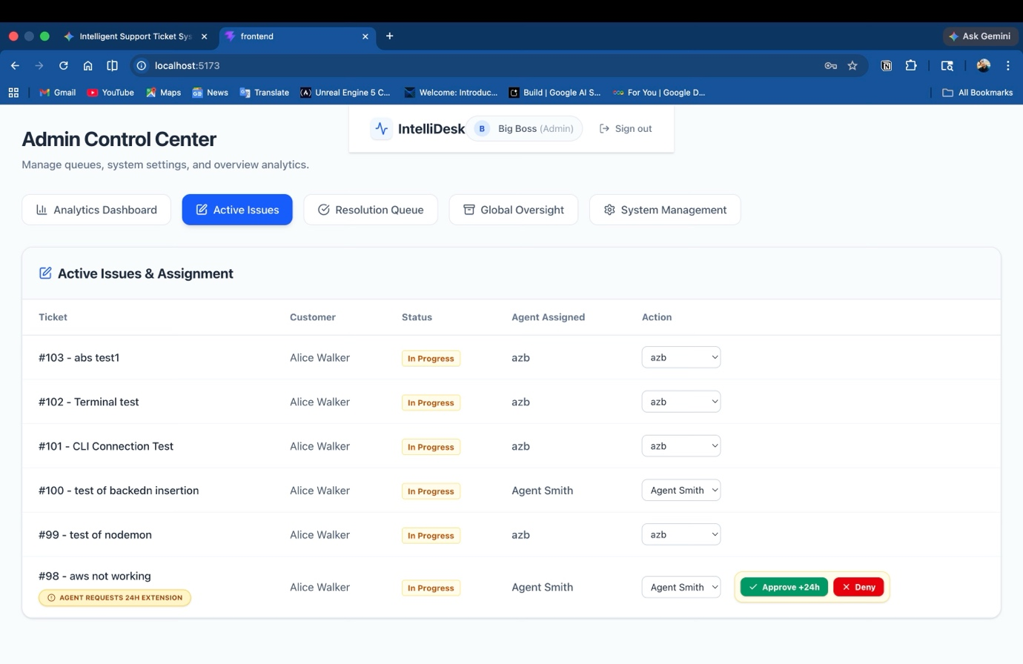
Fig. 7.1.7 View Of Active Issues
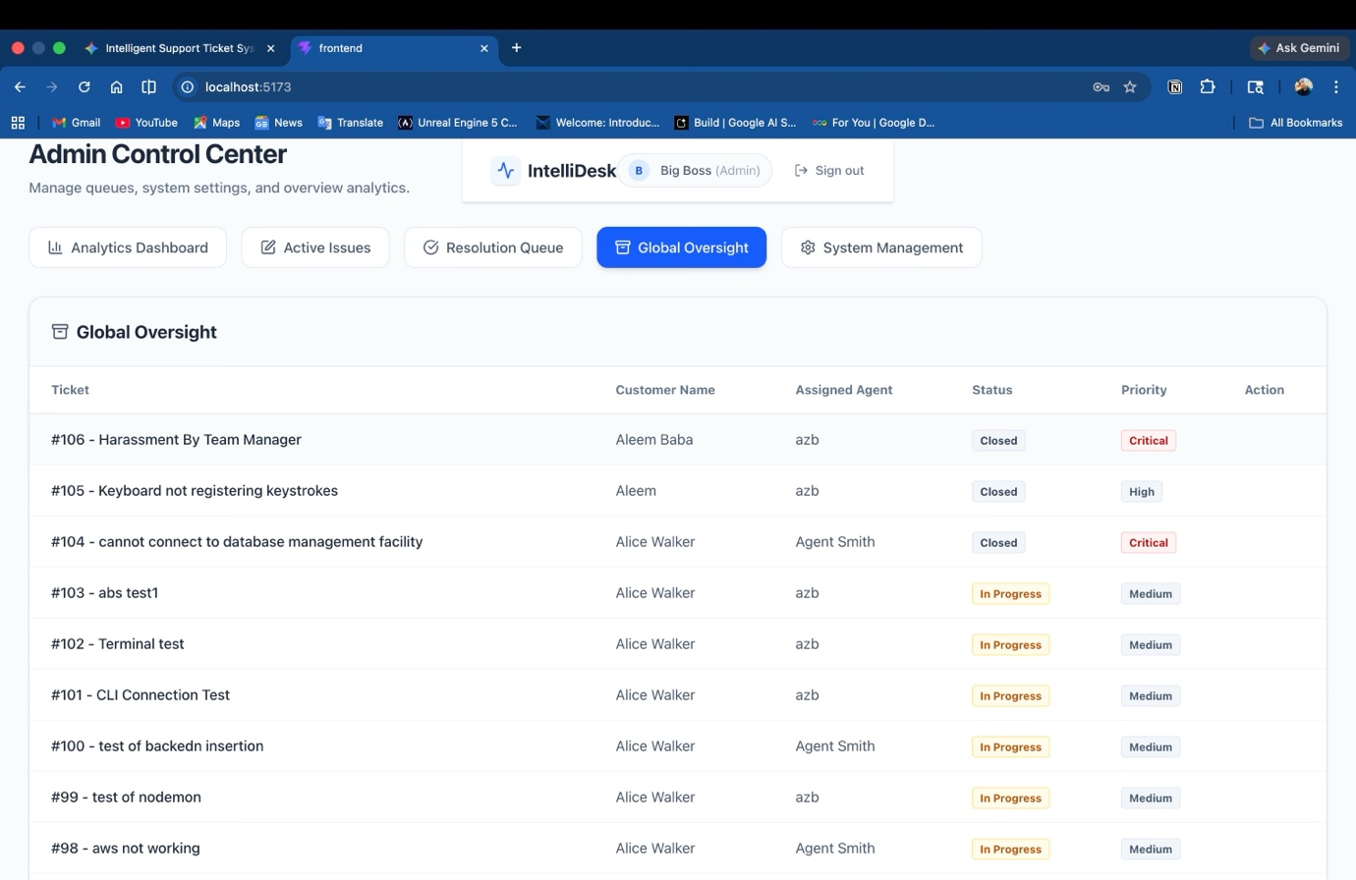
Fig. 7.1.8 Oversight Of All Issues

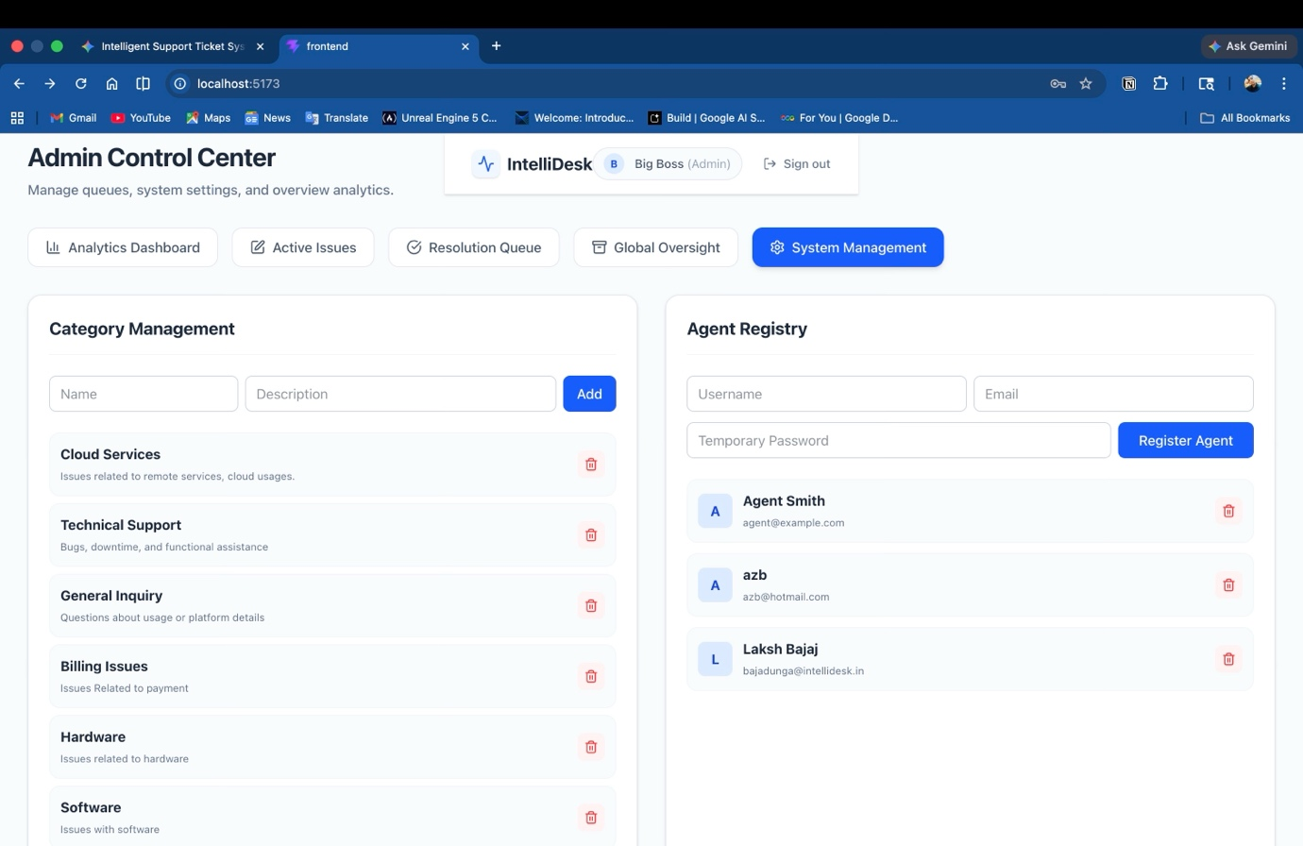
Fig. 7.1.9 Agent Registry Management and Category Management

7.2 Screenshots of Database:

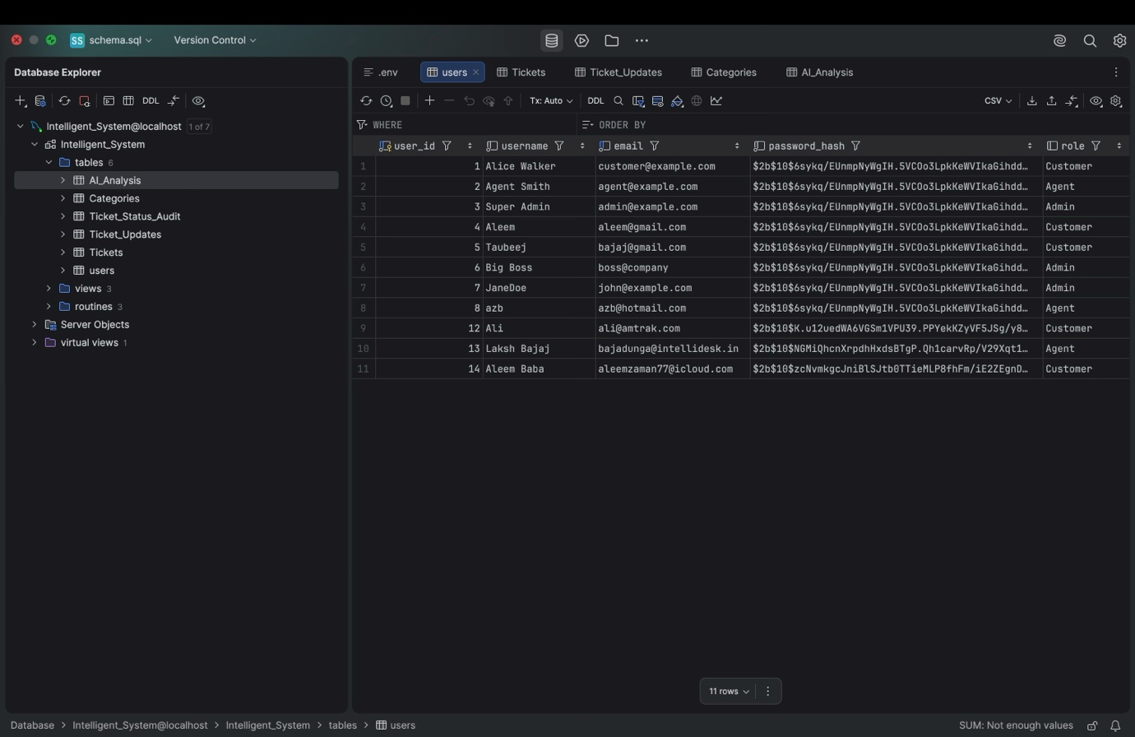
Fig. 7.2.1 User Table
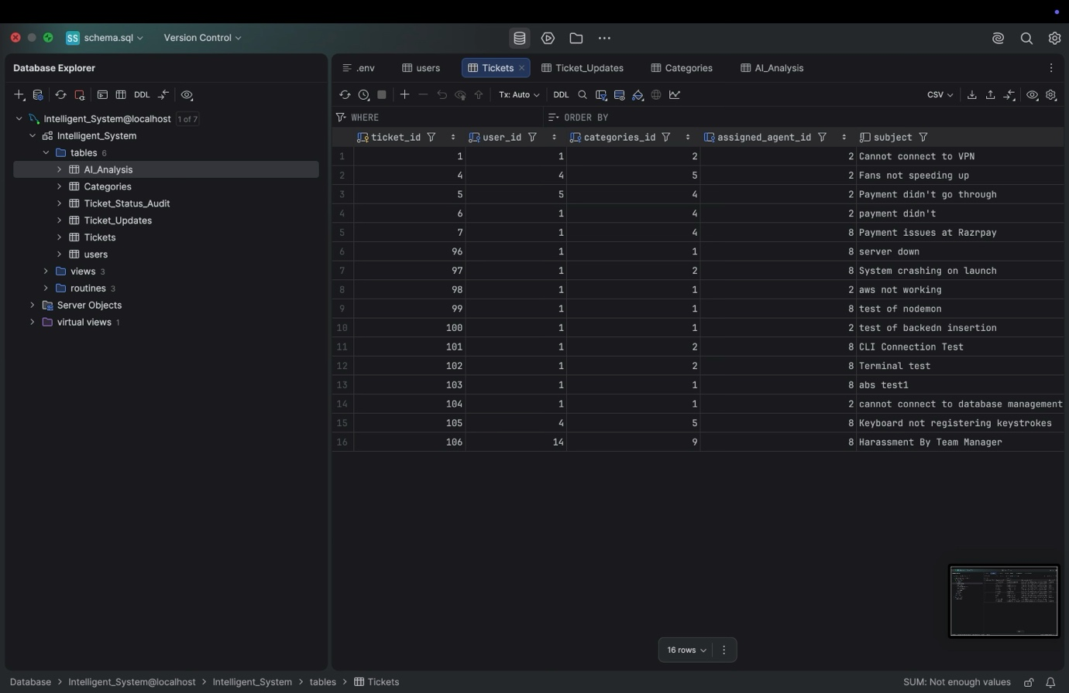
Fig. 7.2.2 Tickets Table
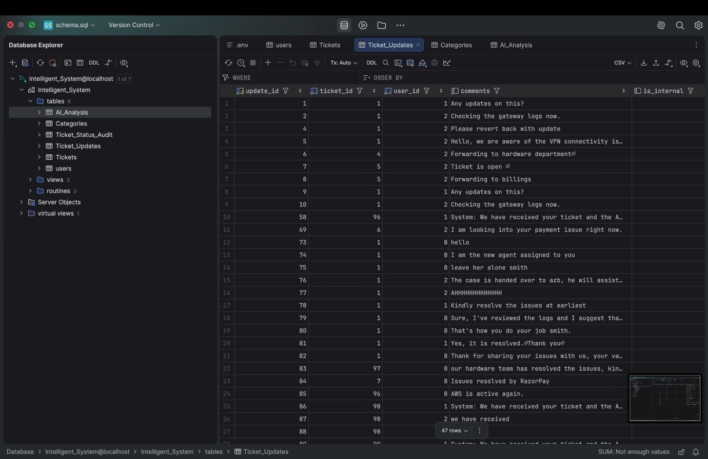
Fig. 7.2.3 Ticket_Updates Table

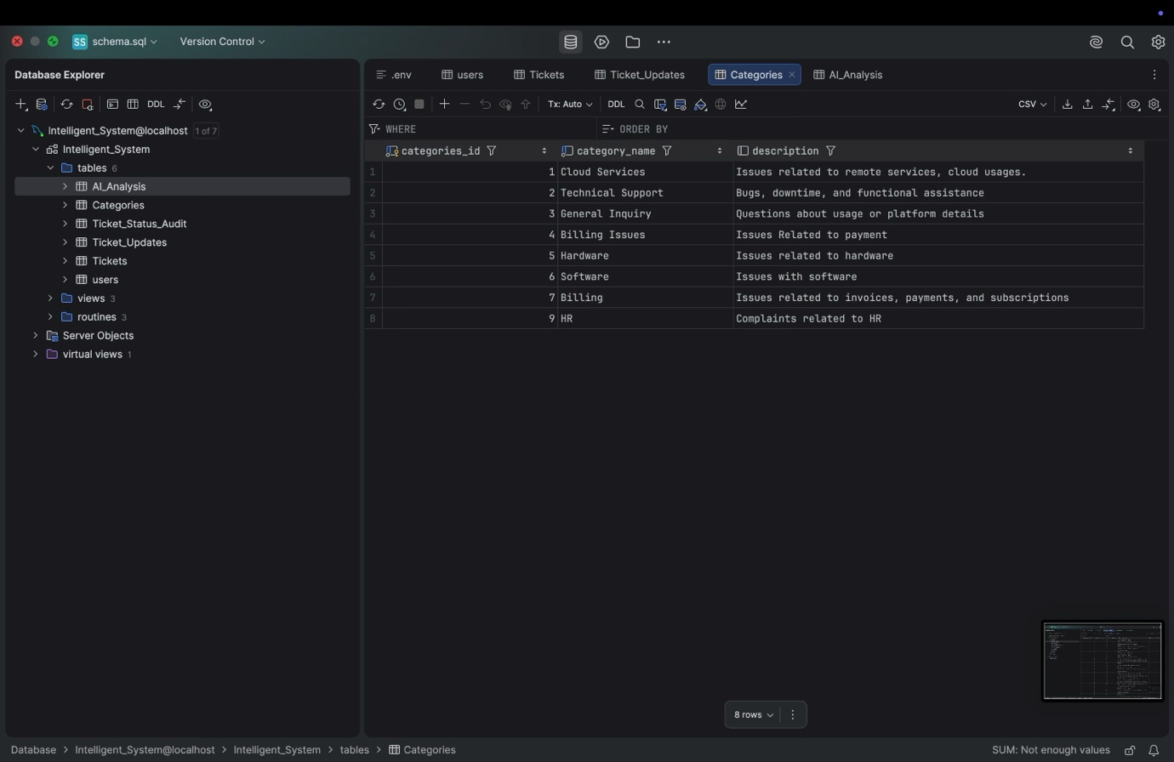
Fig.7.2.4 Categories table
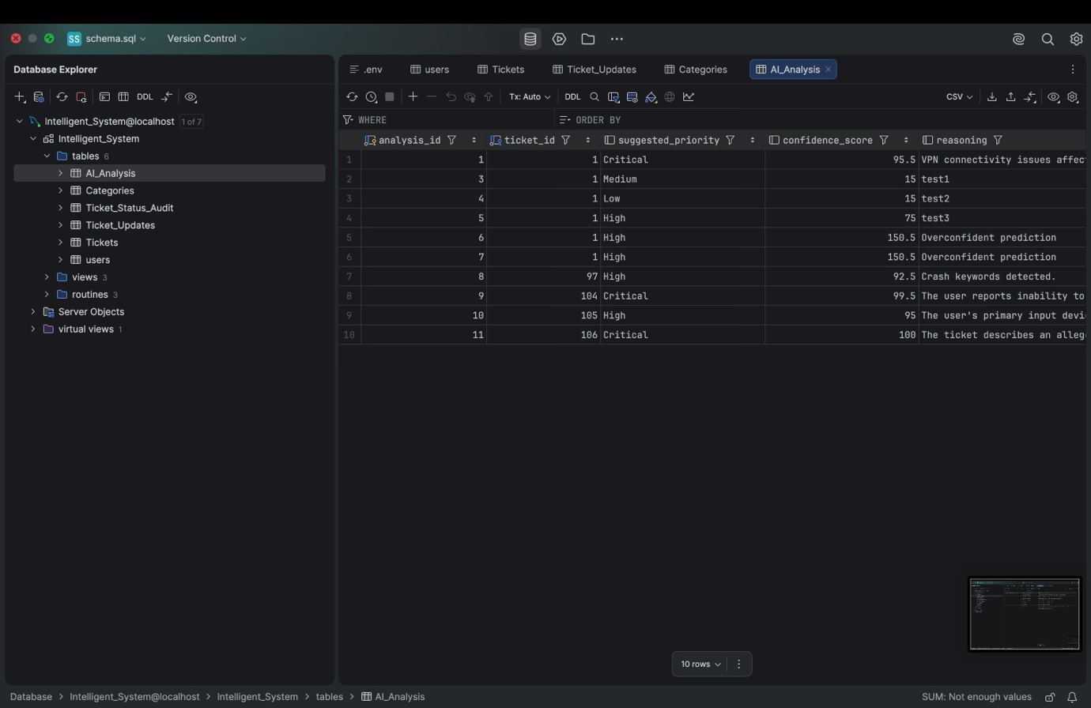
Fig. 7.2.5 AI_Analysis Table

References
1. Elmasri, R., & Navathe, S. B. (2015). Fundamentals of Database Systems (7th ed.). Pearson. (Concepts on Normalization, ER Modeling, and Concurrency Control).
2. Google Cloud (2026). Gemini API Documentation. Retrieved from https://ai.google.dev/docs (For implementation of the @google/genai SDK and JSON schema generation).
3. React Documentation (2026). React: A JavaScript library for building user interfaces. Retrieved from https://react.dev/
4. MySQL 8.0 Reference Manual. InnoDB Locking and Transaction Model. Retrieved from https://dev.mysql.com/doc/refman/8.0/en/innodb-locking.html
5. Express.js API Reference. Fast, unopinionated, minimalist web framework for Node.js. Retrieved from https://expressjs.com/

